DISSERTATION PROJECT REPORT
“Financial Distress Prediction Using Analytics: An Empirical Study Using Classification Models”
Submitted in partial fulfillment of the requirements of the PGDM – AICTE Approved for the award of degree in


POST GRADUATE DIPLOMA IN MANAGEMENT
Submitted by: Shrestha Sarkar PG24299
Under the guidance of: Prof. Jaswanth Singh G Visiting Professor


2024-2026

DISSERTATION PROJECT REPORT
“Financial Distress Prediction Using Analytics: An Empirical Study Using Classification Models”

Submitted in partial fulfillment of the requirements of the PGDM – AICTE Approved for the award of degree in

POST GRADUATE DIPLOMA IN MANAGEMENT
Submitted by: Shrestha Sarkar PG24299
Under the guidance of: Prof. Jaswanth Singh G Visiting Professor
2024-2026

STUDENT DECLARATION

I hereby declare that this report titled “A STUDY ON FINANCIAL DISTRESS PREDICTION USING ANALYTICS”, submitted by me to ISBR Business School in partial fulfillment of requirements of PGDM program is a bonafide work carried out by me under the guidance of Prof. Jaswanth. This has not been submitted to any other University or Institution for the award of any degree/diploma certificate or published any time before.

Name: Shrestha Sarkar
Register no: PG24299 Signature of the candidate Place: Bangalore
Date:08/04/2026

ACKNOWLEDGEMENT

I wish to acknowledge my sincere gratitude to DR. NILA CHOTAI, Academic Director, ISBR Business School for her valuable support during the course of my Dissertation project.

I acknowledge the support extended by Dr. Balaji Shetty, HOD of Finance PGDM department in carrying out this DISSERTATION project.

I extend my thanks to Prof. Jaswanth for his deep involvement and inspiration in carrying out this DISSERTATION project.

Date:08/04/2026 Shrestha Sarkar
Place: Bangalore PG24299

ABSTRACT
This study examines the financial performance and predicts financial distress of selected companies using financial ratios and machine learning techniques. The data used in the study is secondary in nature and collected from Kaggle, covering twelve companies from different industries. Key financial ratios such as liquidity, profitability, and leverage were analyzed to understand the financial condition of the firms.
The study applies statistical methods including descriptive analysis and correlation analysis, along with predictive models such as logistic regression, decision tree, and random forest. The results show that liquidity and profitability indicators, especially Current Ratio and Return on Assets (ROA), are the most significant predictors of financial distress.
The machine learning models demonstrated high accuracy, with decision tree and random forest models providing better prediction performance compared to logistic regression. The study also finds that inflation has a limited impact on corporate profitability.
Overall, the findings of this study help investors, managers, and financial analysts in identifying financially distressed companies and making better financial decisions.

Plagiarism Report

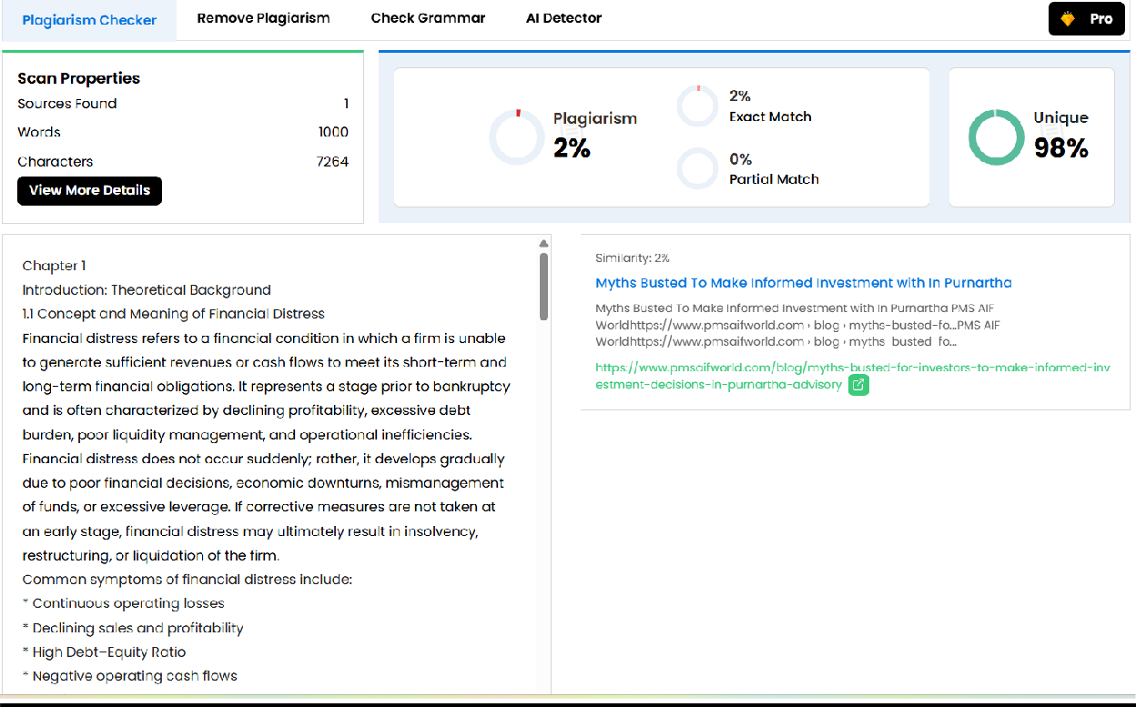

TABLE OF CONTANTS

Body of the Project | 10 - 14
Chapter 1: Introduction: Theoretical Background  - Concept & Meaning of Financial Distress  - Significance of Financial Distress Prediction  - Theoretical Foundation of Financial Distress  - Theoretical Basis of Prediction Analysis  - Need for the Study  - Scope of the Study | 15 – 18  15  15-16  16  16 – 17  17 - 18  18
Chapter 2: Literature Review  - Evolution of Financial Distress Prediction  - Key Findings of Previous Studies  - Research Gap | 19 – 20  19  20  20
Chapter 3: Research Methodology  - Research Approach  - Research Design  - Data Collection  - Variables of the Study  - Analytical Tools Used  - Model Evaluation Criteria | 20 – 22  20  20  21  21  22  22
Chapter 4: Data Collection Source of Data  Descriptive of Data Derived Variables  Data Preparation | 22 – 26  22 – 23  23 – 24  24 – 26  26

Chapter 5: Financial Ratio Analysis  - Current Ratio  - Debt/Equity Ratio  - Return on Assets (ROA)  - Return on Equity (ROE)  - Operating Cash Flow Ratio  - Interest Coverage Ratio  - Return on Capital Employed (ROCE)  - Return on Investment (ROI)  - Significance of Financial Ratio | 26 – 31  27  27 – 28  28  28  29  29  30  30 – 31  31
Chapter 6: Data Analysis and Interpretation  - Individual Company Analysis: Descriptive, Correlation, Trend Analysis  - Apple Inc. (AAPL)  - American International Group Inc. (AIG)  - Amazon.com Inc. (AMZN)  - Barclays PLC (BCS)  - Google (GOOG)  - Intel Corporation (INTC)  - McDonald’s Corporation (MCD)  - Microsoft Corporation (MSFT)  - NVIDIA Corporation (NVDA)  - Pacific Gas and Electric Company (PCG)  - PayPal Holdings Inc. (PYPL)  - Sears Holdings Corporation (SHLDQ) | 32 – 84  32 – 67  32 – 36  36 – 40  41 – 45  45 – 48  48 – 51  51 – 54  54 – 56  56 – 58  58 – 61  61 – 63  63 – 65  66 – 67

- Overall Analysis of the 12 Companies  - Overall Descriptive Analysis  - overall Correlation Analysis  - Overall Trend Observation  - Financial Distress Prediction Model  - Logistic Regression Analysis  - Model Performance Evaluation  - ROC Curve and AUC Analysis  - Decision Tree Model  - Random Forest Model  6.4 Relationship Between Net Profit Margin (NPM) and Inflation Rate | 68 – 71  68 – 69  69 – 70  70 – 71  71 – 81  71 – 73  73 – 74  74 – 75  75 – 78  78 – 81  82 - 84
Chapter 7: Findings, Conclusion, and Recommendation  - Conclusion  - Key Finding of the Study  - Recommendation  - Scope for Future Research  - References  - Appendix | 84 – 89  84 – 85  85 – 86  86  86 – 87  87  88 - 89

BODY OF THE PROJECT
Financial Distress Prediction Using Analytics

CHAPTER 1: INTRODUCTION

Background of the Study
In the modern business environment, companies operate under conditions of high uncertainty due to market fluctuations, competition, regulatory changes, and financial risks. One of the most critical challenges faced by firms is financial distress, which occurs when a company is unable to meet its financial obligations. If not identified at an early stage, financial distress may lead to insolvency or bankruptcy.
With the advancement of data availability and analytical tools, organizations now have the opportunity to use analytics-based models to predict financial distress more effectively. Traditional approaches such as ratio analysis provide limited insights as they fail to capture complex relationships among financial variables. Predictive analytics, on the other hand, enables systematic analysis of historical financial data to forecast future financial conditions.

Concept of Financial Distress
Financial distress refers to a situation in which a firm experiences difficulty in generating sufficient cash flows to meet its short-term and long-term financial commitments. Common indicators include continuous losses, declining profitability, high leverage, liquidity shortages, and negative operating cash flows.
Financial distress is not an overnight event; it develops gradually. Therefore, early detection plays a crucial role in helping management, investors, and lenders take corrective actions to minimize losses.

Role of Analytics in Financial Distress Prediction
Analytics involves the application of statistical and machine learning techniques to identify patterns and trends in data. In financial distress prediction, analytics models such as Logistic Regression and Decision Trees analyze financial ratios and performance indicators to classify firms as distressed or non-distressed.
These models help in:
- Early identification of financially weak firms

- Improved credit risk assessment
- Better investment and lending decisions

Need for the Study
Despite the availability of analytical tools, many organizations still rely on traditional methods for assessing financial health. There is a need to evaluate how effectively analytics-based classification models can predict financial distress using financial indicators. This study aims to address this gap by applying analytical techniques to financial data and assessing their predictive performance.

Scope of the Study
- The study focuses on predicting financial distress using financial ratios.
- The analysis is limited to secondary financial data and survey-based primary data.
- Predictive models used include Logistic Regression and Decision Tree.

CHAPTER 2: REVIEW OF LITERATURE
Previous studies indicate that financial distress prediction has evolved from traditional statistical models to advanced analytics techniques. Earlier research relied heavily on financial ratios and univariate analysis. Later studies introduced multivariate models such as discriminant analysis and logistic regression.
Recent research highlights the growing use of machine learning models for predicting corporate failure. Studies have shown that classification models provide better accuracy in identifying distressed firms compared to conventional methods. Researchers have also emphasized the importance of liquidity, leverage, and profitability ratios in predicting financial distress.
However, most studies focus on advanced models, making them complex and less interpretable. This study emphasizes simple, interpretable, and effective analytics models suitable for practical implementation.

CHAPTER 3: RESEARCH METHODOLOGY

Research Design
The study follows a descriptive and analytical research design. Both primary and secondary data are used to achieve the research objectives.

Data Collection Secondary Data
Secondary data consists of financial statements and financial ratios collected from publicly available sources and datasets. The data is used to develop predictive models for financial distress. Primary Data
Primary data is collected through a structured questionnaire using Google Forms from finance professionals, analysts, and business managers. The survey captures opinions on financial distress indicators and the use of analytics in decision-making.

Variables Used in the Study Dependent Variable:
- Financial Distress (Binary: 1 = Distressed, 0 = Non-Distressed)

Independent Variables:
- Liquidity Ratios
- Profitability Ratios
- Leverage Ratios
- Cash Flow Ratios

Analytical Tools and Techniques
- Data preprocessing using Microsoft Excel
- Descriptive statistics and correlation analysis
- Predictive modeling using Logistic Regression and Decision Tree
- Model evaluation using accuracy, precision, recall, and confusion matrix
- Visualization using Power BI

Model Evaluation Criteria
The performance of predictive models is evaluated based on:
- Accuracy
- Precision
- Recall
- Confusion Matrix
These metrics help assess the effectiveness of the models in classifying distressed and non-distressed firms.

CHAPTER 4: DATA COLLECTION
The current study makes use of secondary data to examine the financial distress in selected companies. The data for the study was obtained from Kaggle, which offers free financial data. The data set includes past financial data of different companies from different sectors.

CHAPTER 5: FINANCIAL RATIO ANALYSIS
Financial ratio analysis is an important tool for financial performance analysis of companies and financial stability of firms. Financial ratio analysis helps to understand the financial position of firms.
- Liquidity Ratios
- Profitability Ratios
- Leverage Ratios
- Cash Flow Ratios

CHAPTER 6: DATA ANALYSIS AND INTERPRETATION
This chapter presents the analysis of financial data and survey responses.
Descriptive analysis highlights key trends in financial ratios between distressed and non-distressed firms. Correlation analysis identifies relationships among financial variables.
Predictive models are developed using Logistic Regression and Decision Tree. The results show that certain financial ratios significantly influence the likelihood of financial distress. Model evaluation metrics indicate the comparative performance of the models, with analytics-based approaches demonstrating strong predictive capability.
Survey responses reveal that most respondents agree that analytics-based models are more effective than traditional methods for early detection of financial distress.

CHAPTER 7: FINDINGS, CONCLUSION, AND RECOMMENDATIONS

Key Findings
- Liquidity and leverage ratios are major indicators of financial distress.
- Analytics-based classification models effectively predict financial distress.

- Logistic Regression provides interpretability, while Decision Tree offers better visualization of decision rules.

Conclusion
The study concludes that analytics plays a significant role in predicting financial distress. Predictive models using financial ratios provide valuable insights for early identification of financially weak firms. The use of analytics enhances the accuracy and reliability of financial risk assessment.

Recommendations
- Organizations should adopt analytics-based models for financial risk monitoring.
- Investors and lenders should incorporate predictive analytics in decision-making.
- Regular monitoring of key financial ratios can help prevent financial failure.

Limitations of the Study
- The study is limited by data availability.
- Advanced machine learning models are not included.
- Results may vary across industries.

Scope for Future Research
- Inclusion of advanced analytics techniques
- Industry-specific financial distress prediction
- Use of real-time financial data

Chapter 1
Introduction: Theoretical Background
  - Concept and Meaning of Financial Distress
Financial distress refers to a financial condition in which a firm is unable to generate sufficient revenues or cash flows to meet its short-term and long-term financial obligations. It represents a stage prior to bankruptcy and is often characterized by declining profitability, excessive debt burden, poor liquidity management, and operational inefficiencies.
Financial distress does not occur suddenly; rather, it develops gradually due to poor financial decisions, economic downturns, mismanagement of funds, or excessive leverage. If corrective measures are not taken at an early stage, financial distress may ultimately result in insolvency, restructuring, or liquidation of the firm.
Common symptoms of financial distress include:
    - Continuous operating losses
    - Declining sales and profitability
    - High Debt–Equity Ratio
    - Negative operating cash flows
    - Inability to repay loans
    - Deterioration in liquidity ratios
From a stakeholder perspective, financial distress has serious consequences. Investors may suffer capital losses, creditors may face repayment risk, and employees may experience job insecurity. Therefore, early identification and prediction of financial distress are critical for financial risk management.

Significance of Financial Distress Prediction
Predicting financial distress at an early stage provides multiple benefits:
    - Enables management to take corrective actions
    - Helps investors avoid risky investments
    - Assists banks and financial institutions in credit risk assessment
    - Supports regulatory authorities in monitoring financial stability

In the modern data-driven business environment, financial distress prediction has become a vital component of risk analytics and corporate governance.

Theoretical Foundations of Financial Distress
- Trade-Off Theory of Capital Structure
The Trade-Off Theory states that firms balance the benefits of debt financing (such as tax advantages) against the costs of financial distress. While debt provides tax shields, excessive borrowing increases bankruptcy risk. When debt levels become too high, the cost of financial distress outweighs its benefits, leading to financial instability.
This theory explains why leverage ratios play a significant role in predicting financial distress.

Agency Theory
Agency Theory suggests that conflicts between managers (agents) and shareholders (principals) may lead to inefficient financial decisions. Managers may engage in risky investments or misuse funds, increasing the firm’s exposure to financial distress.
This theory supports the importance of monitoring financial performance indicators.

Signaling Theory
Signaling Theory proposes that financial indicators and ratios act as signals to external stakeholders regarding the firm’s financial health. Poor liquidity or declining profitability sends negative signals to investors and lenders.
Financial ratios, therefore, serve as measurable indicators for distress prediction.

Theoretical Basis of Predictive Analytics
Predictive analytics refers to the use of statistical and machine learning techniques to forecast future outcomes based on historical data patterns. In financial distress prediction, the objective is to classify firms into:
    - Distressed Firms (1)
    - Non-Distressed Firms (0)

Logistic Regression
Logistic Regression is a statistical classification technique used when the dependent variable is binary. It estimates the probability of financial distress based on independent financial ratios. Advantages:
    - Easy interpretation
    - Probability-based output
    - Suitable for binary classification

Decision Tree
A Decision Tree is a rule-based machine learning model that splits data into branches based on decision rules. It provides clear visualization of how financial ratios lead to classification.
Advantages:
    - Easy to interpret
    - Visual representation
    - Handles non-linear relationships

Random Forest
Random Forest is an advanced machine learning technique used for classification and prediction. It works by creating multiple decision trees and combining their results to improve accuracy.
This method reduces overfitting and provides more reliable predictions compared to a single decision tree. In this study, Random Forest is used to identify important financial variables and predict financial distress.

Need for the Study
The increasing complexity of financial markets and business environments has made it essential to evaluate the financial health of companies more accurately. Traditional financial analysis alone is often insufficient to identify early signs of financial distress, which can lead to significant losses for investors, creditors, and other stakeholders.
This study is needed to understand how financial ratios such as liquidity, profitability, and leverage can be used to assess the financial performance of companies. It also helps in identifying key indicators that signal potential financial distress.
Moreover, with the advancement of technology, machine learning techniques like logistic regression, decision tree, and random forest provide more accurate and efficient tools for

prediction. Therefore, this study integrates both traditional financial analysis and modern predictive models to improve decision-making.
The study is particularly important for:
    - Investors, to make informed investment decisions
    - Financial analysts, to evaluate company performance
    - Managers, to improve financial planning and risk management
Overall, the study helps in early detection of financial distress and better financial decision-making.

Scope of the Study
The scope of this study is limited to analyzing the financial performance and predicting financial distress of selected companies using financial ratios and machine learning techniques.
The study covers:
    - Analysis of twelve companies from different industries such as IT, banking, logistics, semiconductor, retail, and utilities
    - Use of financial data over a specific time period (based on available dataset)
    - Evaluation of key financial ratios including:
      - Liquidity ratios
      - Profitability ratios
      - Leverage ratios
      - Efficiency ratios
    - Examination of the relationship between Net Profit Margin and Inflation Rate
    - Application of statistical and machine learning models such as:
      - Correlation Analysis
      - Logistic Regression
      - Decision Tree
      - Random Forest
The study focuses on identifying the most significant variables influencing financial distress and comparing the effectiveness of different predictive models.
However, the study is limited to the selected companies and variables, and the results may vary if applied to a larger dataset or different industries.

Chapter 2 Literature Review
  - Evolution of Financial Distress Prediction
Financial distress prediction has developed significantly over time as researchers have introduced more advanced methods to improve accuracy and reliability.

Early Studies (Traditional Approach)
In the early stages, traditional approaches such as univariate ratio analysis and discriminant analysis were widely used. Univariate analysis focused on examining individual financial ratios, such as liquidity and profitability, to identify signs of financial weakness. Discriminant analysis, later introduced, allowed researchers to combine multiple financial ratios into a single model to classify firms as distressed or non-distressed. Although these methods provided useful insights, they had limitations in handling complex relationships among variables.

Introduction of Logistic Regression
To overcome these limitations, logistic regression was introduced as a more advanced statistical technique. Logistic regression is particularly suitable for financial distress prediction because it can handle binary outcomes, where a company is classified as either distressed or non-distressed. It also provides probability estimates, which help in understanding the likelihood of financial distress. Logistic regression became widely accepted due to its ability to generate statistically significant coefficients, its ease of interpretation, and its effectiveness in analyzing financial ratios.

Machine Learning Era
In recent years, the focus of research has shifted toward machine learning techniques. Models such as decision trees and random forest have gained popularity due to their ability to handle large datasets and capture complex patterns in financial data. Decision trees provide a simple and visual representation of decision rules, making them easy to understand. Random forest, an ensemble method, improves prediction accuracy by combining multiple decision trees and reducing overfitting. Although these models generally provide higher predictive accuracy, they may be less interpretable compared to traditional statistical methods.

Key Findings from Previous Studies
Most empirical studies conclude that:
    - Liquidity ratios are strong predictors of distress
    - High leverage significantly increases risk
    - Profitability decline is an early warning sign
    - Analytics-based models outperform traditional ratio analysis
However, many advanced models are complex and difficult to implement in practical corporate settings.

Research Gap
Although numerous studies apply sophisticated machine learning algorithms, limited research focuses on:
    - Simpler and interpretable models
    - Practical implementation for managers
    - Combined use of financial ratios with analytics tools accessible to businesses
This study attempts to fill this gap by evaluating Logistic Regression and Decision Tree models for financial distress prediction.

Chapter 3
Research Methodology
  - Research Approach
The study adopts a quantitative research approach. It combines:
    - Descriptive analysis (to understand financial indicators)
    - Analytical modeling (to develop predictive models)

Research Design Type
The research is:
    - Descriptive – To examine financial distress indicators
    - Analytical – To develop and test predictive models

Data Collection Secondary Data
Secondary data is collected from:
    - Financial statements
    - Public financial datasets
    - Multi-year financial data
The data includes financial ratios such as liquidity, leverage, profitability, and cash flow ratios.
    - Finance professionals
    - Risk analysts
    - Business managers

The survey captures perceptions regarding:
    - Key distress indicators
    - Effectiveness of analytics models

  - Variables of the Study Dependent Variable Financial Distress (Binary):
    - 1 = Distressed
    - 0 = Non-Distressed

Independent Variables
    - Current Ratio
    - Debt–Equity Ratio
    - Return on Assets
    - Return on Equity
    - Operating Cash Flow Ratio
    - Interest Coverage Ratio
    - Return on Capital Employed

Analytical Tools Used
    - Microsoft Excel (Data cleaning & preprocessing)
    - Descriptive statistics
    - Correlation analysis
    - Logistic Regression (R)
    - Decision Tree (Python)
    - Random Forest (Python)
    - Model evaluation using:
      - Accuracy
      - Precision
      - Recall
      - Confusion Matrix
    - Power BI (Visualization)

Model Evaluation Criteria
Model performance is evaluated using:
    - Accuracy – Overall correctness of the model
    - Precision – Correct positive predictions
    - Recall – Ability to identify actual distressed firms
    - Confusion Matrix – Classification performance summary These metrics ensure reliable and objective evaluation.

Chapter 4
Data Collection
  - Source of Data
The current study makes use of secondary data to examine the financial distress in selected companies. The data for the study was obtained from Kaggle, which offers free financial data. The data set includes past financial data for 14 Years of 12 different companies from different sectors.

Ticker | Company Name | Industry Category
AAPL | Apple Inc. | Information Technology
AIG | American International Group Inc. | Insurance / Financial Services
AMZN | Amazon.com Inc. | E-commerce / Technology
BCS | Barclays PLC | Investment Banking / Financial  Services
GOOG | Alphabet Inc. (Google) | Technology / Internet Services
INTC | Intel Corporation | Semiconductor / Technology
MCD | McDonald's Corporation | Food & Restaurant
MSFT | Microsoft Corporation | Information Technology
NVDA | NVIDIA Corporation | Semiconductor / Technology
PCG | Pacific Gas and Electric Company | Utility / Energy
PYPL | PayPal Holdings Inc. | Financial Technology
SHLDQ | Sears Holdings Corporation | Retail

The data set comprises financial statement variables and financial ratios that can be used to assess the financial condition of different firms. The data can be used to understand the financial condition of different firms in terms of liquidity, profitability, and leverage.

The data set comprises financial data for different years for different firms. The time-series data can be used to identify patterns that can be linked to financial distress.

Description of Dataset
The dataset includes financial information for twelve different companies in various industry categories.
Each entry in the dataset represents a specific company in a given year. Variables included in the dataset:
These variables are important in providing information about financial information and financial structure for a firm.

Variable | Description
Year | Financial reporting year
Company | Name of the company
Category | Industry sector of the company
Market Cap (in B USD) | Market value of the company
Revenue | Total revenue generated by the company

Gross Profit | Profit after deducting cost of goods sold
Net Income | Final profit after all expenses
Earnings Per Share | Profit earned per share
EBITDA | Earnings before interest, tax, depreciation, and amortization
Shareholder Equity | Total equity held by shareholders
Cash Flow from Operating | Cash generated from operating activities
Cash Flow from Investing | Cash used or generated from investing activities
Cash Flow from Financial  Activities | Cash flow related to financing activities
Current Ratio | Liquidity ratio measuring ability to pay short-term liabilities
Debt/Equity Ratio | Leverage ratio measuring financial risk
ROE | Return on Equity
ROA | Return on Assets
ROI | Return on Investment
Tax Rate | Corporate tax rate
Interest Expense | Interest cost paid on borrowings
Net Profit Margin | Percentage of profit generated from revenue
Free Cash Flow per Share | Cash flow available per share
Return on Tangible Equity | Profit generated from tangible equity
Number of Employees | Total employees in the company
Inflation Rate (US) | Annual inflation rate in the United States

Derived Variables
In addition to the variables available in the dataset, some financial indicators were calculated for the purpose of analysis.
The following variables were computed:

Capital Employed
Capital employed represents the total capital used by a firm to generate profits. It was calculated using shareholder equity and debt.

Calculation:
Step 1: Calculate Total Debt Debt=Debt/Equity Ratio × Shareholder Equity Step 2: Capital Employed
Capital Employed=Shareholder Equity + Total Debt

Return on Capital Employed (ROCE)
ROCE measures the profitability of a company relative to the capital employed in the business. It shows how efficiently a firm uses its capital to generate profits.

Calculation:
ROCE = EBIT / Capital Employed
Since EBIT is not directly available in the dataset, it is approximated using EBITDA. ROCE = EBITDA / Capital Employed

Interest Coverage Ratio
The Interest Coverage Ratio measures the ability of a company to meet its interest obligations. It was calculated using earnings before interest and taxes divided by interest expense.

Calculation:
Interest Coverage Ratio = EBIT / Interest Expenses
Since EBIT is not directly available in the dataset, it is approximated using EBITDA. Interest Coverage Ratio = EBITDA / Interest Expenses

Financial Distress Variable
A binary variable called Distress was created for the analysis. This variable indicates whether a company is financially distressed in a particular year.
The values of the variable are defined as:

Distress =1, if Net Income < 0 or Current Ratio < 1 Distress = 0, otherwise
Value | Meaning
1 | Financially  Distressed
0 | Non-Distressed

Explanation:

Condition | Meaning
Net Income < 0 | The company is making losses
Current Ratio < 1 | The company may not be able to pay short-term  liabilities

If any of these conditions occur, the company is classified as financially distressed (1). Otherwise:
Distress = 0.
This binary variable is used as the dependent variable in the predictive models used in the study.

Data Preparation
Before performing the analysis, the dataset was prepared for modeling. The preparation process included:
    - Checking the dataset for missing values
    - Ensuring consistency in variable names
    - Creating calculated financial ratios
    - Converting the distress variable into a binary format
The cleaned dataset was then used for further statistical and machine learning analysis.

Chapter 5
Financial Ratio Analysis
Financial ratio analysis is an important tool for financial performance analysis of companies and financial stability of firms. Financial ratio analysis helps to understand the financial position of firms.

In the present study, financial ratios are analyzed to understand the financial position of the selected companies. The financial ratios considered for analysis are the Current Ratio, Debt-Equity Ratio, Return on Assets, Return on Equity, Operating Cash Flow Ratio, Interest Coverage Ratio, and Return on Capital Employed. These financial ratios are important to understand the financial position of the firm.

Current Ratio
Current Ratio is a liquidity ratio, and its main purpose is to measure a company's ability to pay its short-term debts. It indicates whether a company is able to meet its current liabilities with its current assets.

The formula for calculating the current ratio is as follows:
Current Ratio = Current Assets / Current liabilities

If a company's current ratio is greater than one, then it means that the company is able to meet its current liabilities with its current assets.

From a company's viewpoint, it is important for a company to maintain a current ratio in order to run its business smoothly. From an investor's viewpoint, current ratio is useful in assessing a company's financial strength in the short term. Companies with a strong current ratio are considered less risky in the financial market.

Debt Equity Ratio
The Debt Equity Ratio is a measure that represents the proportion of debt that a company employs in relation to shareholder equity. The Debt Equity Ratio represents the level of financial leverage that a company employs.

The formula for calculating the Debt Equity Ratio is:
Debt Equity Ratio = Total Debt / Shareholders Equity

The Debt Equity Ratio is high if the company employs a high level of borrowed capital for running its operations. The high Debt Equity Ratio makes a company vulnerable to financial risks since the company has to pay a fixed rate of interest on borrowed capital.

For a company, the level of financial leverage is important in managing growth and financial risks. The Debt Equity Ratio is important for investors since it represents the level of financial

risks that a company employs for growth. Companies in the financial market that employ high leverage are considered to be in a precarious financial position.

Return on Assets (ROA)
The Return on Assets ratio helps us evaluate the efficiency of a company's assets in generating profits. It measures the profitability of a firm relative to its total assets.

The formula for Return on Assets is:
Return On Assets = Net Income / Total Assets

The higher the Return on Assets, the better the company has utilized its assets for generating profits. A company that has a high Return on Assets is said to be efficient in utilizing its assets for generating profits.

From the investor's point of view, the Return on Assets helps them evaluate the efficiency of the management in utilizing the company's assets. It also helps them evaluate the profitability of companies in a particular industry.

Return on Equity (ROE)
Return on Equity is a measure of the rate of return on the investment made by the shareholders. It shows the rate of return on investment to the shareholders of the company.

The formula for Return on Equity is:
Return on Equity = Net Income / Total Shareholder’s Equity

If the Return on Equity is high, it shows that the company is performing well. Companies with high Return on Equity are considered good companies.

For investors, Return on Equity is an important measure of the efficiency of the management. In the financial market, companies with good Return on Equity are considered to have high confidence.

Operating Cash Flow Ratio
The Operating Cash Flow Ratio indicates how well a company is able to meet its short-term debt with cash generated from its operations.

The formula for Operating Cash Flow Ratio is:
Operating Cash Flow Ratio = Cash Flow from Operating / Current Liabilities

It gives us an idea about how well a company is able to generate cash from its operations. The higher the Operating Cash Flow Ratio, the better it is for a company.

For a company, a strong operating cash flow means smooth business operations, and for investors and creditors, it is a significant ratio as it indicates how well a firm is able to meet its financial obligations without relying on external sources.

Interest Coverage Ratio
The interest coverage ratio is a metric that helps companies gauge their ability to service their debt obligations.

The formula for calculating the interest coverage ratio is:
Interest coverage ratio = EBIT / Interest Expenses

A higher interest coverage ratio implies that the company is in a position to service its debt obligations. A lower interest coverage ratio implies that the company is under pressure to service its debt obligations.

For companies, it is important that they have a good interest coverage ratio in order to avoid financial distress.

Return on Capital Employed (ROCE)
The profitability of a business based on the capital employed in the business is measured by the Return on Capital Employed. This measures how well the business is making money based on the capital it has employed.

The formula for ROCE is:
ROCE = EBIT / Capital Employed

The amount of capital that is employed or utilized in business operations is referred to as capital employed.

A business that is well run is one whose Return on Capital Employed is high. A business that is making money based on the capital it has employed is one whose Return on Capital Employed is high.

One of the key performance metrics for investors or players in the market is the Return on Capital Employed. This is an important performance metric for measuring how well a business is making money based on capital investments.

Return on Investment (ROI)
Return on Investment (ROI) is a profitability ratio that measures the efficiency of an investment. It measures how much profit a company makes in relation to the capital that has been invested in the business. ROI is useful in assessing the overall performance of a company.

The formula of ROI is:
Return on Investment = Net Income / Total Investment

In this study, ROI refers to the returns obtained from the capital invested in the company.

A higher ROI suggests that the company is making an efficient use of the investment to generate profits. Conversely, a lower ROI suggests that the company is not making an efficient use of the investment.

From the perspective of the company, ROI is an important financial ratio that helps the company assess the efficiency of business decisions. Companies always try to achieve a higher ROI to enhance their profitability.

From the perspective of investors, ROI is an important financial ratio that helps investors compare different investment options. A higher ROI is always attractive to investors because it implies better returns on their investments.

From the perspective of financial markets, companies with higher ROI are considered to be financially efficient. Hence, ROI is an important financial ratio for assessing the financial efficiency of companies.

Significance of Financial Ratio Analysis
Financial ratio analysis is an important tool for deriving useful insights into the financial well-being of companies. It helps companies identify potential financial problems and take corrective action in a timely manner.

For investors, financial ratios are important tools for evaluating investment options and assessing the financial well-being of companies. In the financial markets, financial ratios are important for comparing companies in different industries and for identifying companies with strong financial performance.

Thus, financial ratio analysis plays an important role in assessing financial stability and potential problems in a firm.

Chapter 6
Data Analysis and Interpretation
  - Individual Company Analysis : Descriptive, Correlation, Trend Analysis
    - Apple Inc. (AAPL)
In this section, the financial analysis of Apple Inc. is conducted using trend analysis, correlation analysis, and descriptive statistics. The purpose of the financial analysis is to understand the financial situation of the company over time.

Descriptive Statistics
Descriptive statistics were calculated to summarize the financial ratios of Apple Inc. over the study period. The statistics include the mean, standard deviation, minimum value, and maximum value of the selected financial variables.

The results show that the average current ratio of Apple Inc. is 1.45, which indicates that the company generally has sufficient current assets to cover its short-term liabilities. However, the minimum value of 0.879 suggests that in some years the company experienced relatively lower liquidity.

The debt–equity ratio has an average value of 0.776, indicating that the company uses both debt and equity to finance its operations. The maximum value of 2.369 shows that the company increased its leverage during some years.

Profitability indicators show strong performance for the company. The average return on equity (ROE) is 61.27%, while the average return on assets (ROA) is 19.13%. These values indicate that the company has been able to generate significant returns from its assets and shareholder investments.

The average return on investment (ROI) is 33.56%, which shows that the company has maintained a strong level of investment efficiency during the study period.

The net profit margin has an average value of 22.53%, which indicates that Apple Inc. has been able to convert a significant portion of its revenue into profit.
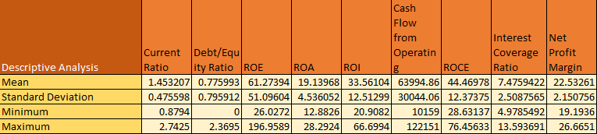

The interest coverage ratio has an average value of 7.47, suggesting that the company has a strong ability to meet its interest obligations. A higher value of this ratio indicates lower financial risk.

The return on capital employed (ROCE) has an average value of 44.47%, which indicates efficient use of capital in generating earnings.

Overall, the descriptive statistics indicate that Apple Inc. has maintained strong profitability and operational efficiency during the study period.

Correlation Analysis
Correlation analysis was used to examine the relationship between different financial factors for Apple Inc. The correlation matrix gives information about how financial indicators move in relation to one another.
The results show a strong positive correlation (0.94) between ROE and ROI, indicating that improvements in return on equity are associated with higher returns on investment. Similarly, ROA and ROI have a strong positive correlation (0.91), suggesting that higher asset efficiency leads to higher investment returns.

The current ratio has a negative correlation with several profitability metrics, such as ROE and ROI. This may imply that increased liquidity does not always result in higher profitability.

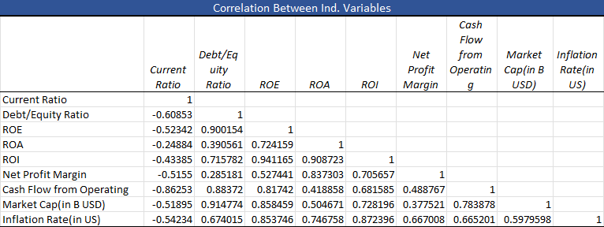

A strong positive correlation is also observed between market capitalization and operating cash flow, which indicates that larger firms tend to generate higher operating cash flows.

The inflation rate shows moderate correlations with several financial variables, suggesting that macroeconomic conditions may influence financial performance to some extent.

Overall, the correlation analysis shows that profitability indicators are closely related to each other, while liquidity and leverage variables show different relationships with profitability measures.

Trend Analysis
Trend analysis was conducted to examine changes in financial ratios of Apple Inc. over time. The trend analysis helps identify patterns in liquidity, leverage, and profitability during the study period.

The current ratio shows a declining trend over the years. The ratio was relatively high in earlier years but gradually decreased in later years, reaching around 0.88 in 2022. This decline indicates that the company’s liquidity position has reduced slightly over time.

The debt–equity ratio shows a significant increasing trend. In the earlier years the value was close to zero, but it gradually increased and reached 2.36 in 2022. This indicates that the company increased its reliance on debt financing over time.
Current Ratio
3

2.5

2

1.5

1

0.5

0
2008 2010 2012 2014 2016 2018 2020 2022 2024
Debt/Equity Ratio
2.5

2

1.5

1

0.5

0
2008 2010 2012 2014 2016 2018 2020 2022 2024

The return on assets (ROA) shows moderate fluctuations over the years. The ratio declined slightly during some years but increased again in recent years, reaching approximately 28.29% in 2022. This indicates improvement in asset efficiency in the later period.

Overall, the trend analysis indicates that Apple Inc. has maintained strong profitability while gradually increasing its financial leverage. Despite the decline in liquidity in recent years, the company continues to demonstrate strong financial performance.
ROA
30

25

20

15

10

5

0
2008 2010 2012 2014 2016 2018 2020 2022 2024

American International Group Inc. (AIG)
This section presents the financial analysis of American International Group Inc. using descriptive statistics, correlation analysis, and trend analysis. The purpose of this analysis is to understand the financial performance of the company over the study period and to examine the relationships between key financial indicators.

Descriptive Statistics
Descriptive statistics were calculated to summarize the financial ratios of AIG during the study period. The statistics include the mean, standard deviation, minimum value, and maximum value of the selected financial variables.

The results show that the average current ratio of AIG is 0.439, which indicates that the company’s liquidity level is relatively low during the study period. The minimum value of 0.372 and the maximum value of 0.55 suggest that the company consistently maintained a current ratio

below one. This indicates that the company may face challenges in meeting short-term obligations using current assets.

The debt–equity ratio has an average value of 0.558, which indicates a moderate level of leverage. The maximum value of 1.155 shows that the company relied more on debt financing during some years.

Profitability indicators show moderate performance for the company. The average return on equity (ROE) is 8.07%, which indicates that the company generates moderate returns for its shareholders. However, the large standard deviation suggests fluctuations in profitability during the study period.
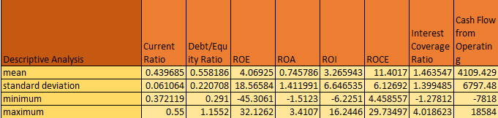

The average return on assets (ROA) is 0.74%, indicating relatively low profitability compared to asset size. The minimum value of -1.51% indicates that the company experienced losses in certain years.

The average return on investment (ROI) is 3.26%, which reflects moderate investment efficiency. Similarly, the average return on capital employed (ROCE) is 11.40%, which indicates the company’s ability to generate returns from the capital invested in the business.

The average interest coverage ratio is 1.46, suggesting that the company has limited ability to cover its interest obligations. A lower interest coverage ratio may indicate higher financial risk.

The net profit margin has an average value of approximately 22.53%, which indicates that the company is able to convert a portion of its revenue into profit.

Overall, the descriptive statistics suggest that AIG has relatively lower liquidity and profitability compared to some other companies in the dataset, with noticeable fluctuations in financial performance during the study period.

Correlation Analysis
Correlation analysis was conducted to examine the relationships between financial variables within AIG. The correlation matrix helps identify how different financial indicators move in relation to each other.

The results show a strong positive relationship between ROA and ROI (0.93), indicating that improvements in asset efficiency are associated with higher investment returns. Similarly, ROE also shows strong positive correlations with ROA and ROI, suggesting that profitability indicators are closely related.

The current ratio shows weak relationships with most profitability indicators, which suggests that liquidity and profitability do not move together strongly in this company.
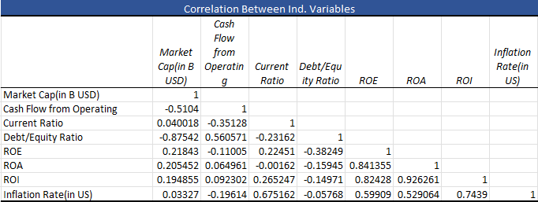

The debt–equity ratio shows negative relationships with profitability variables, indicating that higher leverage may reduce profitability in certain periods.

Market capitalization shows moderate relationships with other financial indicators, suggesting that changes in company size may influence financial performance.

Inflation rate shows moderate correlations with profitability variables, indicating that macroeconomic conditions may influence company performance to some extent.

Overall, the correlation analysis indicates that profitability indicators are strongly related to each other, while liquidity and leverage variables show weaker relationships with profitability.

Trend Analysis
Trend analysis was conducted to examine changes in key financial ratios of AIG over time. This analysis helps identify patterns in liquidity, leverage, and profitability during the study period.

The current ratio shows a gradual increasing trend over the years. The ratio increased from approximately 0.37 in 2009 to 0.55 in 2022, indicating a gradual improvement in the company's liquidity position. However, the ratio remains below one, suggesting that the company still has relatively limited short-term liquidity.
Current Ratio
0.6

0.5

0.4

0.3

0.2

0.1

0
2008
2010
2012
2014
2016
2018
2020
2022
2024

The debt–equity ratio shows fluctuations during the study period. The ratio was relatively high in the earlier years, declined around the middle of the period, and then increased again in recent years. This indicates changes in the company's financing structure over time.

The return on assets (ROA) shows significant fluctuations over the years. In some years the company experienced negative returns, while in other years profitability improved. In recent years, the ROA has shown improvement, reaching approximately 2.14% in 2022.
Debt/Equity Ratio
1.4

1.2

1

0.8

0.6

0.4

0.2

0
2008
2010
2012
2014
2016
2018
2020
2022
2024
ROA
4

3

2

1

0
2
4
-1

-2

008 201 | 0 201 | 2 201 | 4 201 | 6 201 | 8 202 | 0 202 | 2 202

Overall, the trend analysis indicates that AIG experienced fluctuations in profitability and financial structure during the study period. While liquidity has gradually improved, profitability has varied across different years.

Amazon.com Inc. (AMZN)
This section presents the financial analysis of Amazon.com Inc. using descriptive statistics, correlation analysis, and trend analysis. The objective of this analysis is to examine the financial performance of the company during the study period and to understand the relationships between key financial indicators.

Descriptive Statistics
Descriptive statistics were calculated to summarize the financial ratios of Amazon.com Inc. during the study period. The statistics include the mean, standard deviation, minimum value, and maximum value for the selected financial variables.

The results show that the average current ratio of Amazon is 1.11, which indicates that the company generally maintains sufficient liquidity to meet its short-term obligations. The minimum value of 0.9446 suggests that the company experienced relatively lower liquidity in some years, while the maximum value of 1.33 indicates stronger liquidity during earlier years.

The average debt–equity ratio is 0.422, indicating a moderate level of leverage. The maximum value of 0.893 shows that the company relied more on debt financing in certain years, while the minimum value of 0.0329 indicates very low leverage during some periods.

Profitability indicators show moderate performance during the study period. The average return on equity (ROE) is 11.20%, indicating that the company generates reasonable returns for shareholders. However, the high standard deviation indicates fluctuations in profitability.

The average return on assets (ROA) is 3.33%, which suggests that the company generates moderate profit relative to its total assets. The minimum value of -0.5883% indicates that the company experienced lower profitability in some years.

The average return on investment (ROI) is 8.48%, indicating that the company generates moderate returns from its investments.

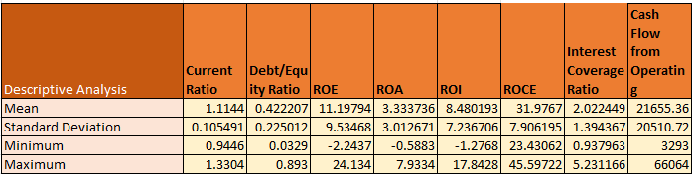

The average return on capital employed (ROCE) is 31.98%, which suggests efficient utilization of capital for generating earnings.

The interest coverage ratio has an average value of 2.02, indicating that the company generally has the ability to meet its interest obligations, although the ratio fluctuates across different years.

The average operating cash flow is approximately 21,655, indicating strong cash generation from operational activities. Market capitalization also shows a high average value of 551.93 billion USD, reflecting the large size and market value of the company.

Overall, the descriptive statistics indicate that Amazon maintains strong liquidity and operational performance, although profitability ratios show some variation over the years.

Correlation Analysis
Correlation analysis was conducted to examine the relationships between financial variables for Amazon.com Inc. The correlation matrix helps identify how financial indicators move in relation to each other.

The results show a very strong positive relationship between ROA and ROI (0.99), indicating that improvements in asset efficiency are closely associated with higher investment returns.

Similarly, ROE shows strong positive relationships with both ROA and ROI, suggesting that profitability indicators are closely related to each other.

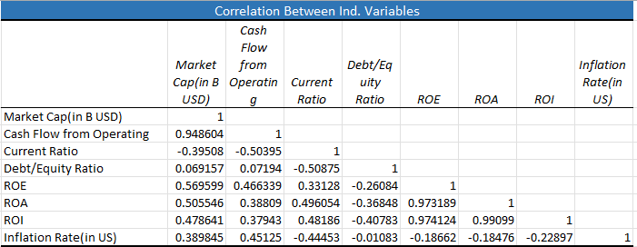

Market capitalization and operating cash flow show a strong positive relationship (0.95), which indicates that increases in operating cash flow are associated with higher market value.

The current ratio shows negative relationships with market capitalization and operating cash flow, suggesting that higher liquidity does not necessarily correspond to larger company size or higher operational cash flow.

Inflation rate shows relatively weak relationships with most financial indicators, indicating that macroeconomic inflation has limited direct impact on the company’s financial ratios.

Overall, the correlation analysis indicates that profitability variables are strongly related to each other, while liquidity and leverage variables show weaker relationships with profitability.

Trend Analysis
Trend analysis was conducted to examine the changes in financial ratios of Amazon over the study period. This analysis helps identify patterns in liquidity, leverage, and profitability over time.

The current ratio shows a slight declining trend over the years. The ratio was relatively higher in earlier years, around 1.33, but gradually declined and reached approximately 0.94 in 2022. This indicates that the company’s liquidity position decreased slightly over time.

The debt–equity ratio shows fluctuations during the study period. The ratio increased during certain years, reaching close to 0.89, and later declined before increasing again in recent years. This suggests changes in the company’s financing strategy.
Current Ratio
1.40
1.20
1.00
0.80
0.60
0.40
0.20
0.00
2008
2010
2012
2014
2016
2018
2020
2022
2024
Debt/Equity Ratio
1
0.9
0.8
0.7
0.6
0.5
0.4
0.3
0.2
0.1
0
2008
2010
2012
2014
2016
2018
2020
2022
2024

The return on assets (ROA) shows noticeable fluctuations across the years. The company experienced both increases and decreases in profitability. In recent years, the ROA shows a decline, reaching a negative value in 2022, which indicates reduced profitability during that period.

008 201 | 0 201 | 2 201 | 4 201 | 6 201 | 8 202 | 0 202 | 2 202

Overall, the trend analysis suggests that Amazon has maintained relatively stable liquidity and leverage levels over the study period. However, profitability indicators show variations, reflecting changes in operational performance and market conditions.
ROA
10
8
6
4
2
0
2
-2
4

Barclays PLC (BCS)
This section presents the financial analysis of Barclays PLC using descriptive statistics, correlation analysis, and trend analysis. The objective is to examine the financial condition and performance of the company during the study period.

Descriptive Statistics
The descriptive statistics show significant variation in the financial ratios of BCS during the study period.

The average current ratio is 4.48, indicating strong liquidity during the earlier years. However, the large standard deviation suggests high fluctuations in liquidity levels. The maximum value of
11.41 indicates very high liquidity in some years.

The average debt–equity ratio is 6.28, which indicates a very high level of financial leverage. This suggests that the company relied heavily on debt financing.

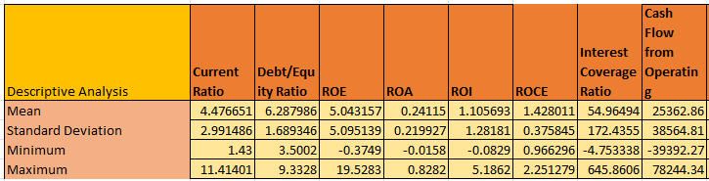

Profitability indicators also show fluctuations. The average ROE is 5.04%, while the average ROA is 0.24%, indicating relatively low profitability compared to the high level of leverage.

The average ROI is 1.10%, and the average ROCE is 1.43%, suggesting limited efficiency in generating returns from invested capital.

The interest coverage ratio shows a high average value, but the large variation indicates instability in the company’s ability to meet interest obligations.

Overall, the descriptive statistics indicate that BCS had high leverage and unstable profitability during the study period.

Correlation Analysis
The correlation matrix shows strong relationships between profitability indicators.
There is a very strong positive correlation between ROA and ROI (0.99), indicating that increases in asset profitability lead to higher investment returns. ROE also shows strong relationships with ROA and ROI.

The current ratio shows weak relationships with most profitability variables, suggesting that liquidity changes do not strongly influence profitability.

The debt–equity ratio shows negative relationships with profitability indicators, which suggests that higher leverage may reduce financial performance.

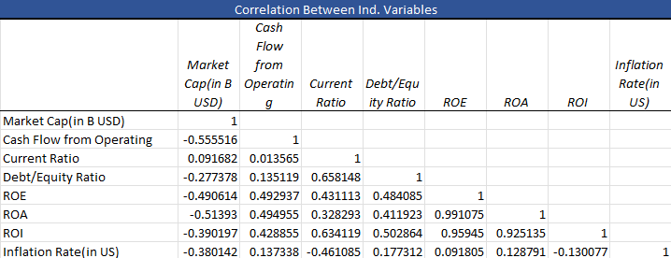

Overall, profitability indicators are strongly related to each other, while liquidity and leverage show weaker relationships with profitability.

Trend Analysis
The trend analysis shows noticeable changes in the financial performance of BSC during the study period.

The current ratio shows a sharp declining trend from 11.41 in 2009 to about 1.43 in 2022, indicating a significant reduction in liquidity over time.
Current Ratio
12.00
10.00
8.00
6.00
4.00
2.00
0.00
2008
2010
2012
2014
2016
2018
2020
2022
2024

The debt–equity ratio shows fluctuations but remains at a high level, reflecting the company’s reliance on debt financing.

The return on assets (ROA) shows fluctuations, with lower profitability in some years and moderate improvement in later years.
Debt/Equity Ratio
10

8

6

4

2

0
2008
2010
2012
2014
2016
2018
2020
2022
2024
ROA
1
0.8
0.6
0.4
0.2
0
2
-0.2
4

008 201 | 0 201 | 2 201 | 4 201 | 6 201 | 8 202 | 0 202 | 2 202

Overall, the trend analysis suggests that BSC experienced declining liquidity and unstable profitability during the study period.

Google (Alphabet Inc.)
This section presents the financial analysis of Google based on descriptive statistics, correlation analysis, and trend analysis.

Descriptive Analysis
The descriptive statistics show that Google maintained strong financial performance during the study period.

The average current ratio is 4.71, which indicates a strong liquidity position. The high maximum value of 10.62 suggests that the company maintained a large amount of current assets relative to its short-term liabilities.

The debt–equity ratio is very low with a mean of 0.046, indicating that Google relies very little on debt financing and mainly operates with equity funding.
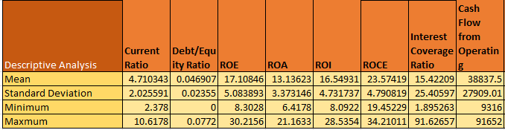

Profitability indicators show stable performance. The average ROA is 13.14%, ROE is 17.11%, and ROI is 16.55%, which reflects efficient use of assets and investments.

The average ROCE is 23.57%, indicating that the company generates strong returns from its capital employed.

Overall, the descriptive results show that Google has strong liquidity, low leverage, and high profitability.

Correlation Analysis
The correlation results show strong relationships among profitability variables.
There is a very strong positive relationship between ROA and ROI, indicating that higher asset profitability leads to higher investment returns. ROE also shows a strong positive relationship with ROA.

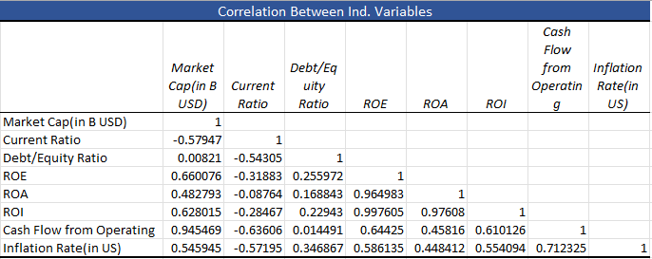

The current ratio shows negative relationships with debt–equity ratio, suggesting that higher liquidity is associated with lower financial leverage.

Market capitalization and cash flow from operations show strong positive relationships with profitability variables, indicating that company growth is closely related to financial performance.

Trend Analysis
The trend analysis shows stable financial performance over the study period.
The current ratio shows a declining trend, moving from a high level in earlier years toward more stable levels in recent years. This suggests improved efficiency in managing current assets.

The debt–equity ratio remains very low across the years, which indicates a conservative financial structure with limited reliance on debt.

The ROA trend shows fluctuations but generally remains at a high level, reflecting consistent profitability and efficient asset utilization.

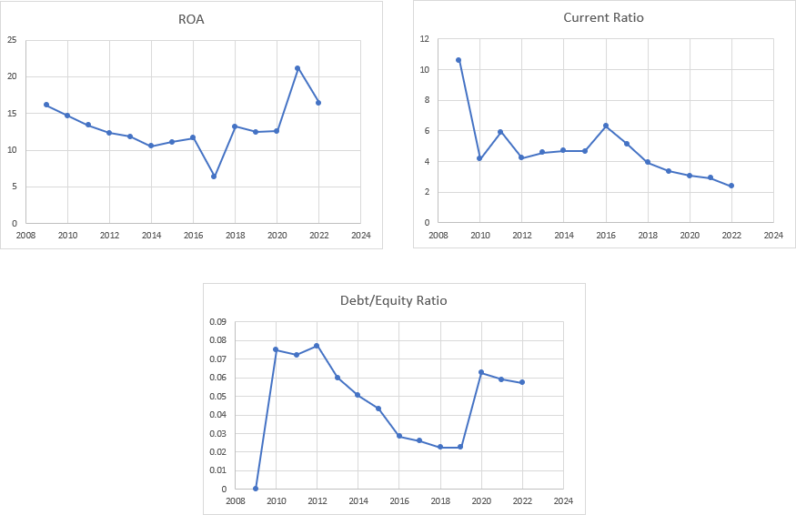

Overall, the trend analysis indicates that Google maintains strong liquidity, low financial risk, and stable profitability.

Intel Corporation (INTC)
This section analyzes the financial performance of Intel Corporation using descriptive statistics, correlation analysis, and trend analysis.

Descriptive Analysis
The descriptive statistics indicate moderate liquidity and stable profitability for Intel during the study period.

The average current ratio is 2.11, indicating that the company maintained sufficient liquidity to meet short-term obligations. The mean debt–equity ratio is 0.29, suggesting moderate use of debt financing compared to equity.

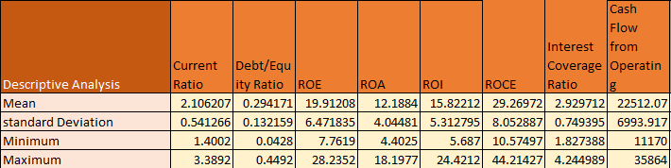

Profitability indicators show relatively strong performance. The average ROE is 19.91%, ROA is 12.19%, and ROI is 15.82%, indicating efficient utilization of assets and investments.
The average ROCE is 29.27%, which reflects strong returns generated from the company’s capital employed.

Overall, the descriptive statistics indicate that Intel maintained a balanced financial structure with moderate leverage and stable profitability.

Correlation Analysis
The correlation results show strong relationships among profitability indicators.
There is a very strong positive relationship between ROA and ROI, indicating that higher asset profitability leads to higher investment returns. ROE also shows a strong positive relationship with both ROA and ROI.
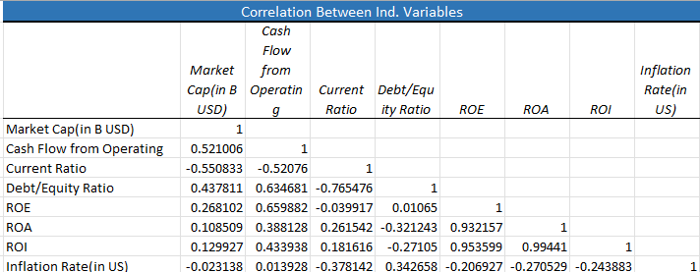

The current ratio shows negative relationships with market capitalization and cash flow from operations, suggesting that higher liquidity does not necessarily correspond with company size or operational cash flows.

Inflation rate shows weak negative relationships with profitability variables, indicating that macroeconomic conditions may slightly influence company performance.

Trend Analysis
The trend analysis indicates fluctuations in Intel’s financial performance over the study period. The current ratio shows fluctuations but generally remains above 1, indicating stable liquidity conditions. The debt–equity ratio shows an increasing trend over time, suggesting that the company gradually increased its reliance on debt financing. The ROA trend shows variability, with strong performance in earlier years followed by a decline in recent years, indicating changes in asset profitability.

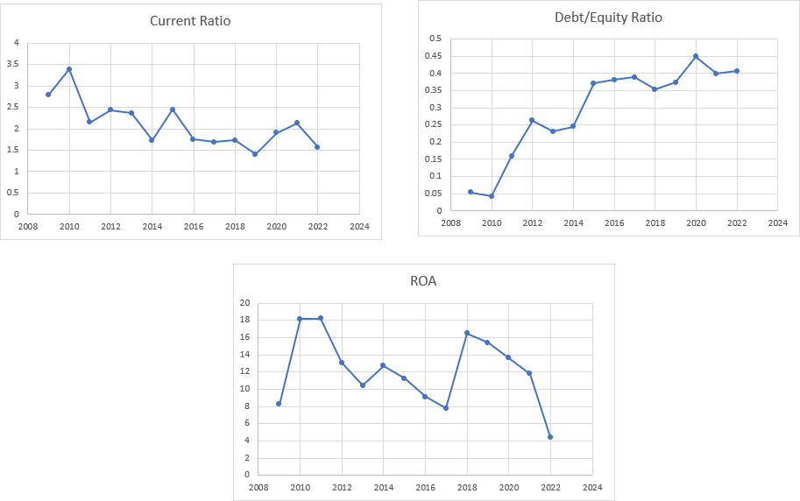

Overall, the trend analysis suggests that Intel maintained stable liquidity but experienced fluctuations in profitability during the study period.

McDonald’s Corporation (MCD)
This section analyzes the financial performance of McDonald’s Corporation using descriptive statistics, correlation analysis, and trend analysis.

Descriptive Analysis
The descriptive statistics indicate stable liquidity and strong profitability for McDonald’s during the study period.
The average current ratio is 1.54, which indicates that the company maintained adequate liquidity to meet short-term obligations.The debt–equity ratio shows a negative average value, reflecting the company’s unique capital structure where liabilities exceed equity in some periods due to share repurchases and financial restructuring.
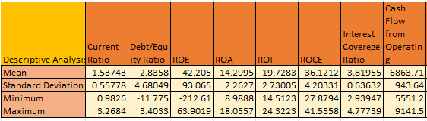

Profitability indicators show strong performance. The average ROE is 42.21%, ROA is 14.30%, and ROI is 19.73%, indicating efficient use of assets and strong shareholder returns. The average ROCE is 36.12%, which suggests that McDonald’s generates high returns from its capital employed.

Overall, the descriptive statistics indicate that McDonald’s maintained strong profitability despite fluctuations in its capital structure.

Correlation Analysis
The correlation analysis shows strong relationships between profitability indicators. There is a very strong positive relationship between ROE and ROA, indicating that improvements in asset efficiency contribute significantly to shareholder returns.

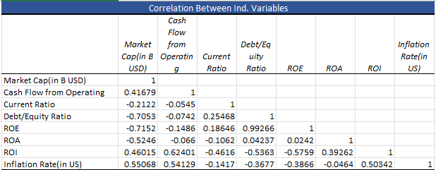

Market capitalization and cash flow from operations show positive relationships with profitability indicators, suggesting that company growth is supported by operational performance.

The current ratio shows weak relationships with profitability variables, indicating that liquidity changes do not significantly affect profitability.

Trend Analysis
The trend analysis shows fluctuations in McDonald’s financial performance over the study period. The current ratio shows moderate variation but remains around stable levels, indicating consistent liquidity management.

The debt–equity ratio shows significant fluctuations, including negative values in some years, reflecting structural changes in the company’s financing strategy.

The ROA trend remains relatively stable, indicating consistent profitability and efficient asset utilization over time.

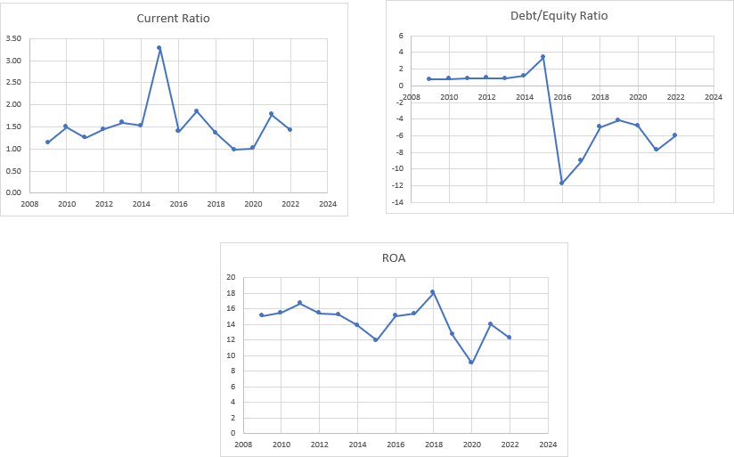

Overall, the trend analysis suggests that McDonald’s maintained strong profitability while experiencing changes in its financial structure.

Microsoft Corporation (MSFT)
This section examines the financial performance of Microsoft Corporation using descriptive statistics, correlation analysis, and trend analysis.

Descriptive Analysis
The descriptive statistics show strong financial performance and stable liquidity for Microsoft during the study period. The average current ratio is about 2.38, which indicates that the company maintained sufficient liquidity to meet short-term obligations.

The average debt–equity ratio is around 0.29, suggesting that Microsoft uses a moderate level of debt financing while still relying mainly on equity.

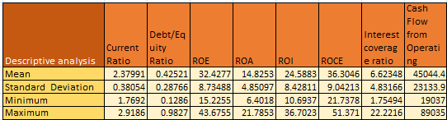

Profitability indicators show strong results. The average ROE is approximately 32.43%, ROA is 14.83%, and ROI is 24.59%, indicating efficient utilization of company assets and investments. The average ROCE is about 36.30%, which shows that Microsoft generates high returns from its capital employed.

Overall, the descriptive results indicate that Microsoft maintains strong profitability with a balanced financial structure.

Correlation Analysis
The correlation matrix shows strong relationships between profitability indicators. There is a very strong positive relationship between ROA and ROI, indicating that higher asset efficiency leads to higher investment returns. ROE also shows strong positive relationships with ROA and ROI.
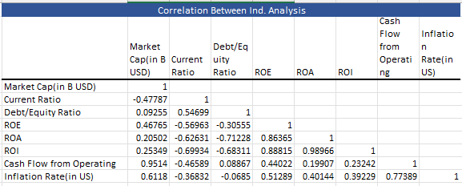

Cash flow from operations shows a positive relationship with profitability variables, suggesting that strong operational performance supports the company’s financial growth. The current ratio

shows weak relationships with profitability indicators, indicating that liquidity changes do not significantly influence profitability.

Trend Analysis
The trend analysis indicates stable financial performance for Microsoft over the study period. The current ratio shows moderate fluctuations but remains above 1, indicating consistent liquidity management. The debt–equity ratio increased gradually until around 2017 and then declined, suggesting adjustments in the company’s financing structure. The ROA trend shows fluctuations but remains relatively strong, indicating consistent profitability and efficient use of assets.

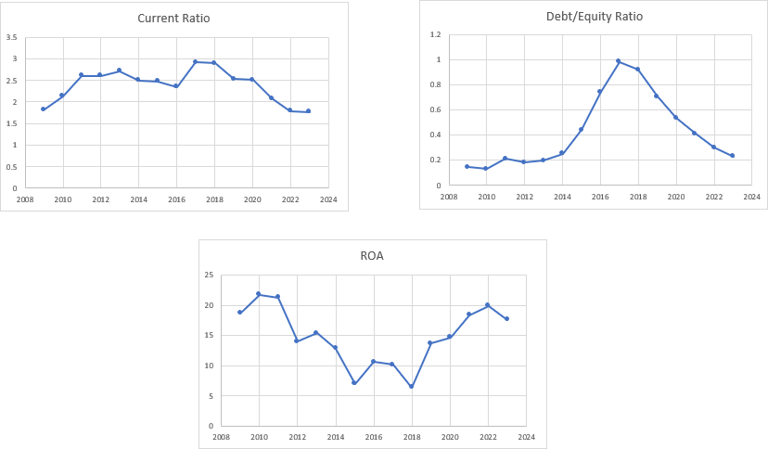

Overall, the trend analysis suggests that Microsoft maintains stable liquidity, moderate leverage, and strong profitability.

NVIDIA Corporation (NVDA)
This section examines the financial performance of NVIDIA Corporation using descriptive statistics, correlation analysis, and trend analysis.

Descriptive Analysis
The descriptive statistics indicate strong liquidity and improving profitability for NVIDIA during the study period. The average current ratio is approximately 5.07, which indicates a strong liquidity position and the ability of the company to meet short-term obligations comfortably.

The average debt–equity ratio is about 0.23, showing that NVIDIA maintains a relatively low level of financial leverage and relies more on equity financing. Profitability indicators show good performance. The average ROE is around 19.11%, ROA is 12.29%, and ROI is 15.34%, indicating effective use of assets and investments.
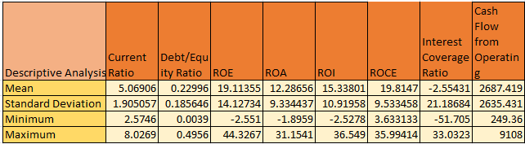

The average ROCE is about 19.81%, suggesting that the company generates solid returns from its capital employed.

Overall, the descriptive results indicate that NVIDIA maintains strong liquidity with moderate profitability and relatively low financial risk.

Correlation Analysis
The correlation matrix shows strong relationships among profitability indicators.
There is a very strong positive relationship between ROA and ROI, indicating that improvements in asset profitability directly contribute to higher investment returns. ROE also shows a strong positive relationship with both ROA and ROI. Cash flow from operations shows positive relationships with most financial variables, suggesting that operational performance supports the company’s financial growth.

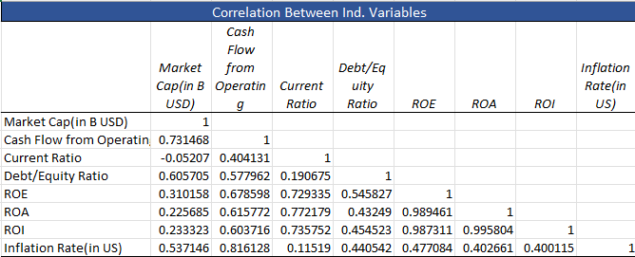

The current ratio shows only weak relationships with profitability variables, indicating that liquidity does not strongly affect profitability.

Trend Analysis
The trend analysis shows noticeable changes in NVIDIA’s financial performance over the study period.

The current ratio shows fluctuations but remains relatively high, indicating strong liquidity throughout most of the years.

The debt–equity ratio increased gradually in recent years, suggesting a moderate increase in the company’s use of debt financing.

The ROA trend shows significant improvement after the mid-period, reflecting increased profitability and improved asset utilization in recent years.

Overall, the trend analysis suggests that NVIDIA experienced improving profitability while maintaining strong liquidity and manageable leverage.

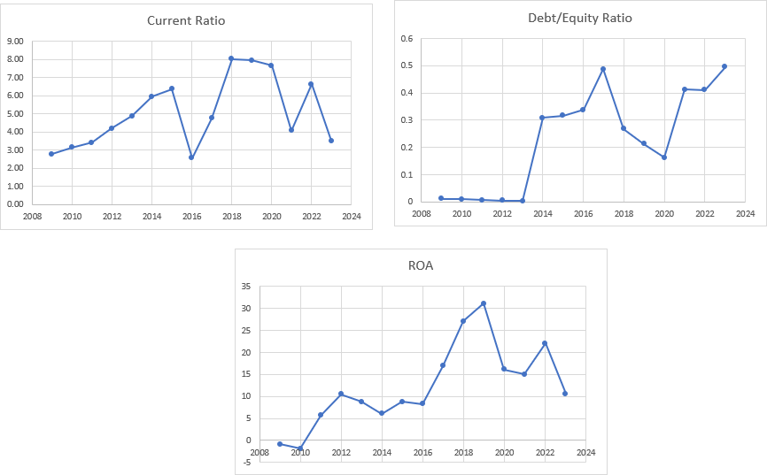

Pacific Gas & Electric Company (PCG)
This section analyzes the financial performance of Pacific Gas & Electric Company using descriptive statistics, correlation analysis, and trend analysis.

Descriptive Analysis
The descriptive statistics indicate weak liquidity and unstable profitability for PCG during the study period. The average current ratio is about 0.82, which is below 1 and indicates that the company may face difficulty in meeting short-term obligations.
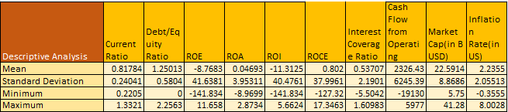

The average debt–equity ratio is approximately 1.25, showing a relatively high dependence on debt financing compared to equity. Profitability indicators show instability. The average ROE is

negative, and ROA and ROI also show negative values in several years, indicating weak financial performance and inefficient utilization of assets. The average ROCE is around 0.80, suggesting that the company generates very low returns from its capital employed.
Overall, the descriptive statistics indicate that PCG experienced financial difficulties and unstable performance during the study period.

Correlation Analysis
The correlation analysis shows moderate relationships among financial variables.
ROA and ROI show a positive relationship, indicating that asset efficiency contributes to investment returns.
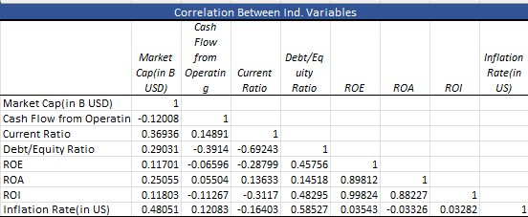

The current ratio shows a negative relationship with the debt–equity ratio, suggesting that higher leverage reduces liquidity. Cash flow from operations shows a positive relationship with profitability indicators, indicating that operational performance plays an important role in the company’s financial condition.

Trend Analysis
The trend analysis indicates fluctuations in PCG’s financial condition during the study period.
The current ratio remains below 1 in most years, indicating persistent liquidity pressure. The debt–equity ratio shows an increasing trend in recent years, suggesting a rising dependence on debt financing.

The ROA trend shows large fluctuations and negative values in some years, reflecting unstable profitability and financial stress.

Overall, the trend analysis suggests that PCG experienced weak liquidity and unstable profitability during the study period.

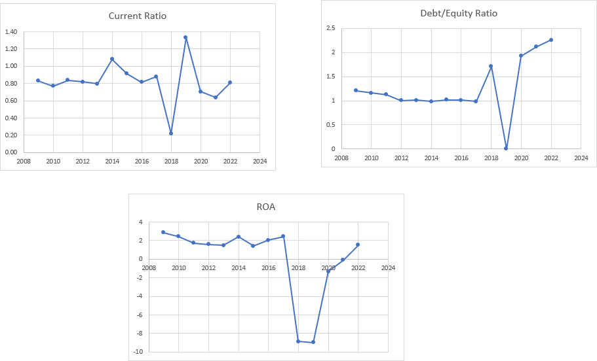

PayPal Holdings Inc. (PYPL)
This section analyzes the financial performance of PayPal Holdings Inc. using descriptive statistics, correlation analysis, and trend analysis.

Descriptive Analysis
The descriptive statistics show stable liquidity and good profitability for PayPal during the study period. The average current ratio is about 1.37, indicating that the company has sufficient current assets to meet short-term obligations.

The average debt–equity ratio is around 0.22, which suggests that the company uses relatively low financial leverage and relies more on equity financing.
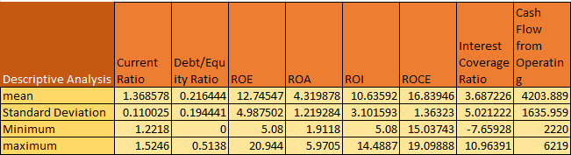

Profitability indicators show positive performance. The average ROE is about 12.75%, while ROA and ROI are also positive, indicating efficient use of assets and investments. The average ROCE is approximately 16.84, suggesting that the company generates good returns from its capital employed.

Overall, the descriptive statistics indicate a financially stable and profitable position for PayPal.

Correlation Analysis
The correlation analysis shows strong relationships between profitability variables. ROE, ROA, and ROI show strong positive correlations, indicating that improvements in asset efficiency lead to higher shareholder returns.
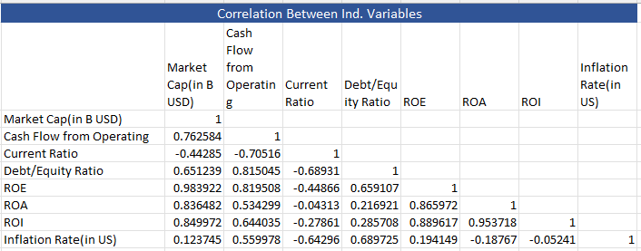

The debt–equity ratio shows a negative relationship with the current ratio, suggesting that higher leverage may reduce liquidity. Cash flow from operations shows a positive relationship with profitability indicators, indicating that operational performance supports financial stability.

Trend Analysis
The trend analysis indicates relatively stable financial performance during the study period. The current ratio remains above 1 in all years, indicating strong liquidity. The debt–equity ratio shows an increasing trend in recent years, suggesting a gradual increase in financial
leverage. The ROA trend shows improvement until around 2020 and then a slight decline in recent years, but it remains positive overall.
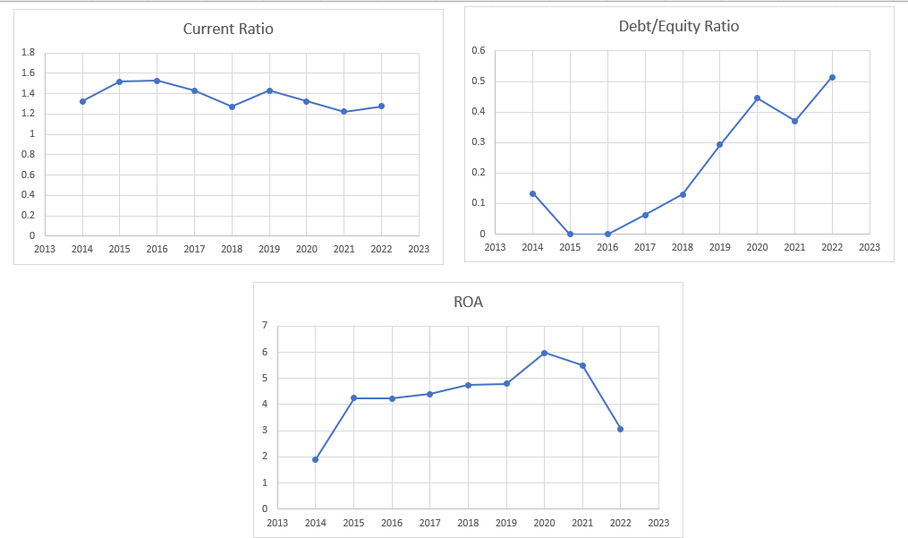

Overall, PayPal demonstrates stable liquidity, moderate leverage, and consistent profitability during the study period.

Sears Holdings Corporation (SHLDQ)
This section analyzes the financial performance of Sears Holdings Corporation using descriptive statistics, correlation analysis, and trend analysis.

Descriptive Analysis
The descriptive statistics indicate poor financial performance and financial distress for Sears during the study period. The average current ratio is about 1.13, which appears acceptable, but the company still faced liquidity pressure due to declining operations. The debt–equity ratio shows unstable values, including negative values in several years, indicating financial instability and high financial risk.
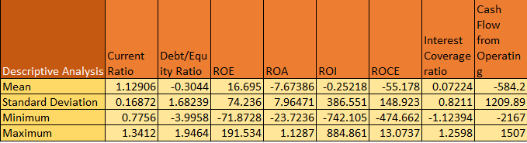

Profitability indicators are weak. ROA and ROI show negative average values, which means the company was not able to generate sufficient profit from its assets and investments. The average ROCE is also negative, indicating inefficient utilization of capital employed. Overall, the descriptive statistics suggest that Sears experienced serious financial difficulties during the study period.

Correlation Analysis
The correlation analysis shows moderate relationships among financial variables.
ROA and ROI show a positive relationship, indicating that asset performance affects investment returns. The current ratio has a positive relationship with cash flow from operations, suggesting that better operational cash flow improves liquidity. However, profitability variables show unstable relationships due to the company’s weak financial condition.

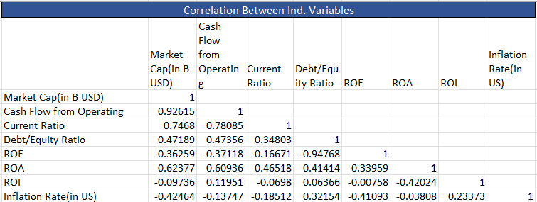

Trend Analysis
The trend analysis shows a decline in financial performance over the years. The current ratio shows a decreasing trend, indicating worsening liquidity. The debt–equity ratio fluctuates significantly, reflecting unstable capital structure. The ROA trend shows large negative values in several years, indicating continuous operating losses. Overall, the trend analysis confirms that Sears experienced severe financial distress during the study period.

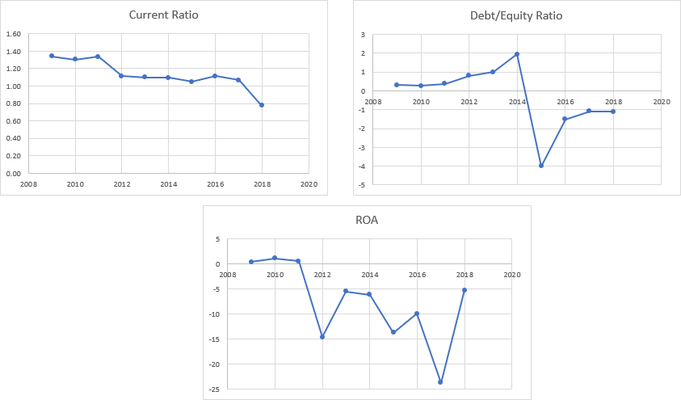

Overall Analysis of the 12 Companies
After analyzing each company individually, this section presents the overall analysis of all twelve companies together. The objective is to understand the general financial behavior of the companies and identify the variables that influence financial distress.

The analysis includes descriptive statistics, correlation analysis, and trend observations of the selected financial variables.

Overall Descriptive Analysis
Descriptive statistics provide a general understanding of the distribution and variation of financial ratios among the selected companies.

The average current ratio across the companies is greater than one, which indicates that most companies maintain sufficient current assets to meet their short-term obligations. However, the standard deviation shows variation in liquidity positions among the firms.

The debt–equity ratio varies widely among companies. Some firms rely more on debt financing while others maintain a relatively lower level of financial leverage. High variation in this ratio indicates differences in capital structure across the companies.
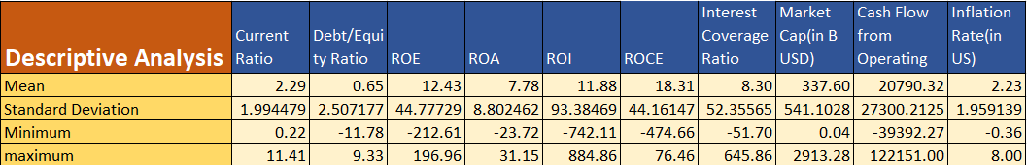

Profitability ratios such as Return on Equity (ROE), Return on Assets (ROA), and Return on Investment (ROI) show positive mean values, which indicates that most companies generate returns from their operations and assets. However, the presence of negative minimum values suggests that some companies experienced financial difficulties during certain years.

The Return on Capital Employed (ROCE) also shows positive average values, indicating that several companies utilize their capital efficiently to generate profits.

The interest coverage ratio reflects the ability of companies to meet their interest obligations. Higher values indicate stronger financial stability, while lower values may signal financial stress. The cash flow from operating activities shows significant variation among companies. Firms with higher operating cash flow demonstrate stronger operational performance and financial stability.

Overall, the descriptive analysis suggests that while many companies maintain stable financial performance, some firms exhibit weaker profitability and liquidity, which may indicate financial distress.

Overall Correlation Analysis
Correlation analysis is used to examine the relationships between financial variables and identify how they move together.

The results indicate a strong positive relationship between profitability ratios such as ROE, ROA, and ROI. This suggests that companies that efficiently use their assets tend to generate higher returns for investors.

The current ratio shows a negative relationship with the debt–equity ratio, indicating that companies with higher leverage may experience lower liquidity. Cash flow from operations shows a positive relationship with profitability indicators, suggesting that strong operational cash flow supports better financial performance.

Market capitalization also shows positive relationships with several financial indicators, which indicates that larger companies generally maintain stronger financial positions. Inflation rate shows relatively weaker correlations with financial ratios, suggesting that macroeconomic conditions influence companies indirectly rather than directly.

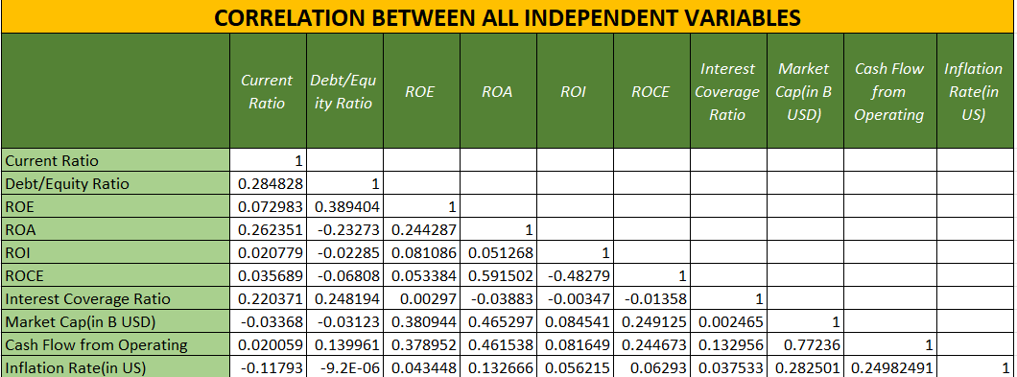

Overall, the correlation results indicate that profitability ratios and operating cash flow play an important role in determining the financial performance of companies.

Overall Trend Observations
The trend analysis across the selected companies shows noticeable variations in financial performance over the study period.

Liquidity ratios such as the current ratio fluctuate across companies but remain stable for many large firms. Companies experiencing financial distress show declining liquidity trends. The debt–equity ratio shows increasing trends for some companies, indicating greater reliance on debt financing over time.

Profitability indicators such as ROA and ROE show improvements for technologically advanced companies, while financially weak firms demonstrate declining profitability. The analysis also shows that companies with consistent operating cash flows tend to maintain stable financial performance and lower probability of financial distress.

Overall, the trend analysis highlights differences in financial stability among companies, with stronger firms maintaining steady performance and weaker firms experiencing financial decline.

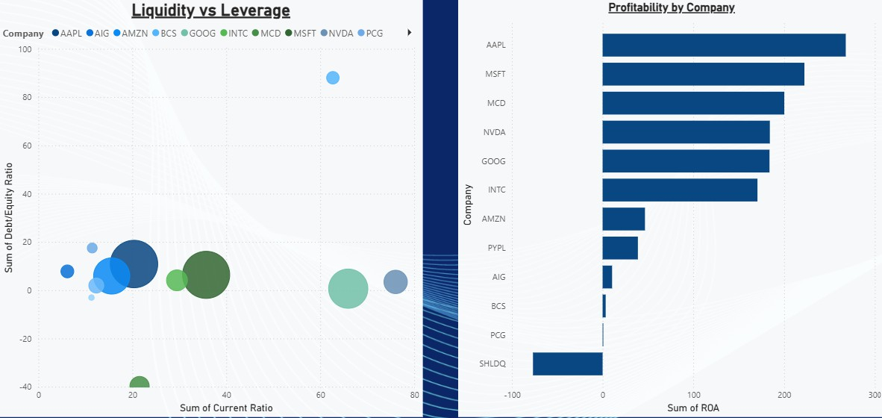

Financial Distress Prediction Models
To identify the key financial variables that influence corporate financial distress, predictive models were developed using machine learning and statistical techniques. The models used in this study include Logistic Regression, Decision Tree, and Random Forest.
These models help classify companies into distressed and non-distressed categories based on selected financial ratios and economic indicators.

Logistic Regression Analysis
Logistic regression is used to examine the relationship between financial ratios and the probability of financial distress. The dependent variable in the model is the financial distress indicator, which takes the value 1 for distressed companies and 0 for non-distressed companies.
The independent variables used in the model include:
      - Current Ratio
      - Debt–Equity Ratio
      - Return on Assets (ROA)
      - Interest Coverage Ratio
      - Cash Flow from Operating Activities
      - Inflation Rate

The logistic regression results are presented in the table.

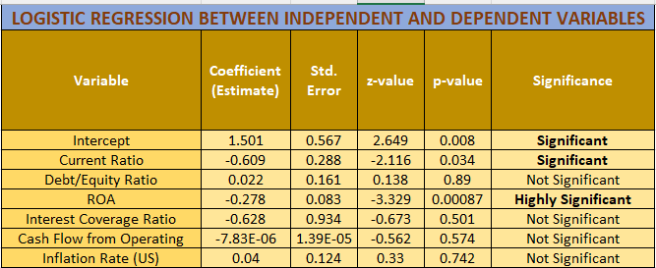

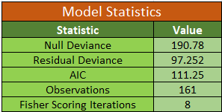

Interpretation of Logistic Regression Results
The results indicate that Current Ratio and Return on Assets (ROA) have statistically significant effects on financial distress.

The current ratio shows a negative coefficient, indicating that higher liquidity reduces the probability of financial distress. Companies with sufficient current assets are more capable of meeting short-term obligations and maintaining financial stability.

The ROA variable is highly significant, suggesting that profitability plays an important role in determining the financial health of companies. Firms with higher returns on assets are less likely to experience financial distress.

Other variables such as debt–equity ratio, interest coverage ratio, operating cash flow, and inflation rate do not show strong statistical significance in the model.

Overall, the logistic regression analysis suggests that liquidity and profitability are key factors influencing financial distress.

Model Performance Evaluation
To evaluate the effectiveness of the logistic regression model, several performance metrics were calculated using the confusion matrix.

Confusion Matrix Table
Actual / Predicted | Non-Distress (0) | Distress (1)
Non-Distress (0) | 103 | 13
Distress (1) | 7 | 38

Meaning
Term | Value
True Negative (TN) | 103
False Positive (FP) | 13
False Negative (FN) | 7
True Positive (TP) | 38

The model correctly classified 141 out of 161 observations, resulting in an overall accuracy of 87.58%. The sensitivity (recall) of the model is 88.79%, which indicates that the model correctly identifies a large proportion of distressed companies. The specificity value is 84.44%, meaning that the model effectively identifies non-distressed companies as well. The precision value of 93.64% indicates that most companies predicted as distressed are actually distressed.
The balanced accuracy of 86.62% shows that the model performs well across both classes. The Kappa statistic of 0.7037 indicates a strong agreement between the predicted and actual classifications.

Model Performance
Metrics
Metric | Value
Accuracy | 87.58%
Sensitivity (Recall) | 88.79%
Specificity | 84.44%
Negative Predictive  Value | 74.51%
Precision (Positive Predictive Value) | 93.64%
Balanced Accuracy | 86.62%
Kappa Statistic | 0.7037

ROC Curve and AUC Analysis
The Receiver Operating Characteristic (ROC) curve was used to evaluate the classification ability of the model. The Area Under the Curve (AUC) value is 0.9393, which falls within the range of 0.90 – 1.00, indicating excellent model performance. A high AUC value means that the model has strong ability to distinguish between distressed and non-distressed companies. The statistical tests also show that the model performs significantly better than random classification.

Model Statistical Tests
Test | Value
No Information Rate | 0.7205
P-value (Accuracy > NIR) | 1.81E-06
McNemar Test p-value | 0.2636
ROC Result
Metric | Value
AUC | 0.9393
AUC Range | Model Quality
0.90 – 1.00 | Excellent

Overall, the results indicate that the logistic regression model provides reliable predictions of financial distress based on selected financial ratios.

Decision Tree Model
In addition to logistic regression, a decision tree model was developed to classify companies into distressed and non-distressed categories. Decision tree models are widely used in financial analysis because they provide a clear and interpretable structure for identifying important variables affecting financial distress.
The model uses the same independent variables as the logistic regression model:
      - Current Ratio
      - Debt–Equity Ratio
      - Return on Assets (ROA)
      - Interest Coverage Ratio
      - Cash Flow from Operating Activities
      - Inflation Rate
The decision tree algorithm splits the dataset based on the most informative financial ratios in order to classify companies according to their financial condition.

Model Performance
The decision tree model produced very strong classification results.
Out of 49 test observations, the model correctly classified all observations, resulting in 100% accuracy.
The confusion matrix shows:

Confusion Matrix
Actual / Predicted | Non-Distress (0) | Distress  (1)
Non-Distress (0) | 37 | 0
Distress (1) | 0 | 12

This means:
      - True Negatives (TN) = 37
      - True Positives (TP) = 12

      - False Positives (FP) = 0
      - False Negatives (FN) = 0
The classification report shows that precision, recall, and F1-score for both classes are equal to 1, which indicates perfect classification performance.

Classification Report
Class | Precision | Recall | F1-  Score | Support
Non-Distress (0) | 1 | 1 | 1 | 37
Distress (1) | 1 | 1 | 1 | 12

These results suggest that the decision tree model is highly effective in identifying distressed and non-distressed firms in the dataset.

Model Performance
Metric | Value
Model Accuracy | 1.00 (100%)
Total Test  Observations | 49
Correct Predictions | 49
Incorrect Predictions | 0

Variable Importance
The decision tree model also identifies the most important financial variables influencing financial distress.

The variable importance ranking is as follows:

Variable Importance (Decision Tree)
Rank | Variable | Importance  Score
1 | Current Ratio | 0.6529
2 | ROA | 0.3084

3 | Interest Coverage Ratio | 0.0387
4 | Debt/Equity Ratio | 0
5 | Cash Flow from Operating | 0
6 | Inflation Rate (US) | 0

The current ratio is the most influential variable, indicating that liquidity plays a crucial role in determining whether a company experiences financial distress. The return on assets (ROA) is the second most important variable, suggesting that profitability significantly affects financial stability. Other variables such as debt–equity ratio and inflation rate have relatively lower influence in the decision tree model.

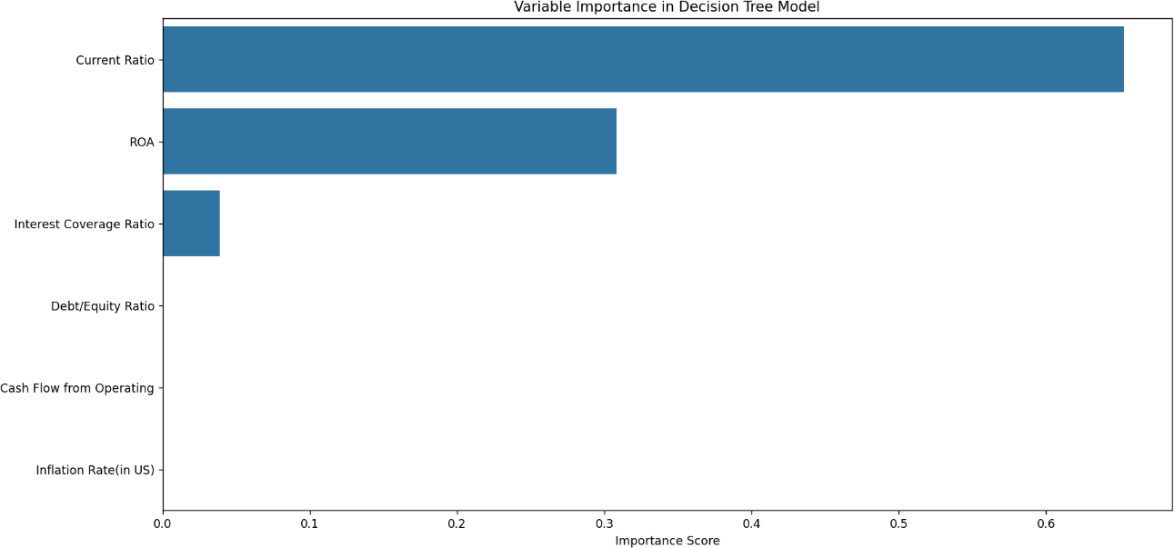

Interpretation
The decision tree model demonstrates excellent classification performance. The results highlight that liquidity and profitability are the most important determinants of financial distress among the selected companies.

The model also confirms the findings of the logistic regression analysis, where current ratio and ROA were identified as key predictors of financial distress.

Overall, the decision tree provides a simple and effective method for identifying financially distressed firms based on financial ratios.
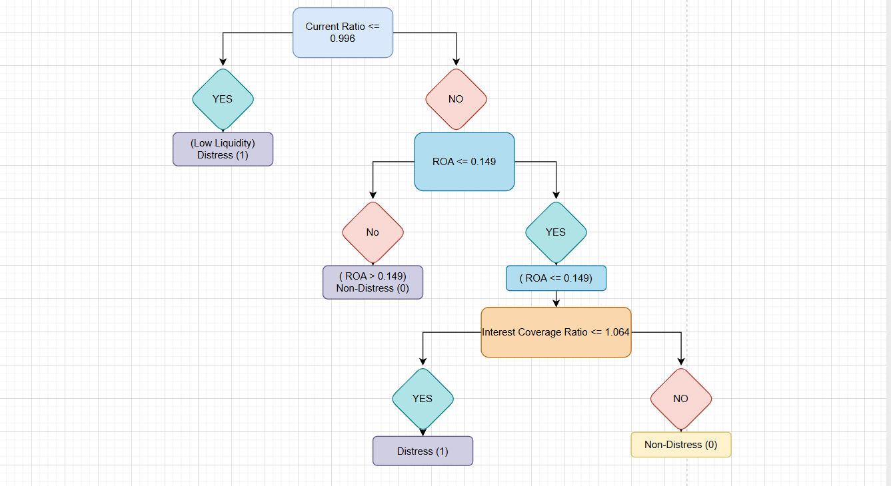

Random Forest Model
To improve prediction performance and capture complex relationships among variables, a Random Forest model was applied. Random Forest is an ensemble machine learning technique that builds multiple decision trees and combines their predictions to produce more accurate and stable results.
The same independent variables used in the previous models were included in the Random Forest analysis:
      - Current Ratio
      - Debt–Equity Ratio
      - Return on Assets (ROA)
      - Interest Coverage Ratio
      - Cash Flow from Operating Activities
      - Inflation Rate
The dependent variable represents the financial distress condition of the firms.

Model Performance
The Random Forest model demonstrated very strong predictive performance.
Out of 49 test observations, the model correctly classified 48 observations, resulting in an

accuracy of 97.96%.

Random Forest Model Performance
Metric | Value
Accuracy | 0.9796 (97.96%)
Test Observations | 49
Correct Predictions | 48
Incorrect Predictions | 1

The confusion matrix results are presented below:

Confusion Matrix
Actual / Predicted | Non-Distress (0) | Distress  (1)
Non-Distress (0) | 36 | 1
Distress (1) | 0 | 12

This indicates that:
      - True Negatives (TN) = 36
      - True Positives (TP) = 12
      - False Positives (FP) = 1
      - False Negatives (FN) = 0
The model correctly identified all distressed firms, while only one non-distressed company was misclassified.
The classification report shows strong performance across both classes. The macro average F1-score is 0.97, and the weighted average F1-score is 0.98, indicating balanced predictive performance.

Classification Report
Class | Precision | Recall | F1-  Score | Support
Non-Distress (0) | 1 | 0.97 | 0.99 | 37
Distress (1) | 0.92 | 1 | 0.96 | 12

Meaning:

Overall Metrics
Metric | Value
Accuracy | 0.98
Macro Avg F1 | 0.97
Weighted Avg F1 | 0.98

Feature Importance
The Random Forest model also identifies the most influential variables affecting financial distress.
The ranking of feature importance is presented below:

Feature Importance (Random Forest)
Rank | Variable | Importance Score
1 | Current Ratio | 0.4208
2 | ROA | 0.2309
3 | Interest Coverage Ratio | 0.2049
4 | Debt/Equity Ratio | 0.069
5 | Cash Flow from Operating | 0.0589
6 | Inflation Rate (US) | 0.0155

The current ratio remains the most important predictor, indicating that liquidity plays a critical role in determining financial distress.
The return on assets and interest coverage ratio also show significant influence, highlighting the importance of profitability and the ability to meet interest obligations.

Macroeconomic variables such as inflation rate have relatively lower importance in predicting company-level financial distress.
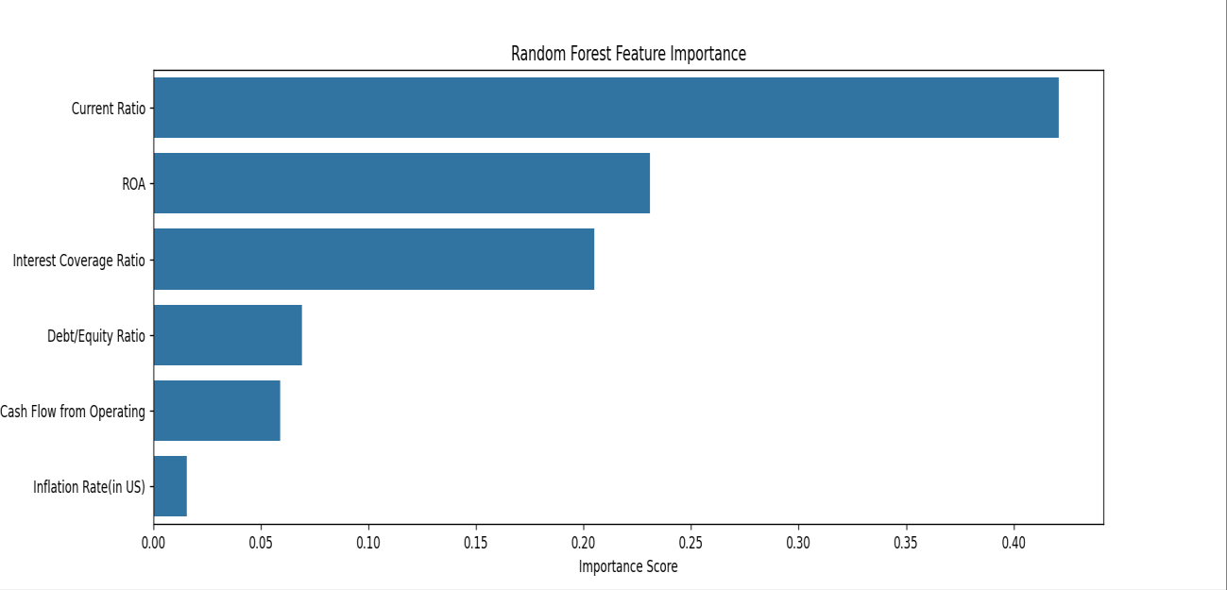

Interpretation
The Random Forest model provides highly accurate predictions and confirms the importance of key financial indicators in determining financial distress.

The results consistently show that liquidity (current ratio), profitability (ROA), and financial stability (interest coverage ratio) are the most important variables influencing corporate financial health.

Compared to logistic regression and decision tree models, the Random Forest model offers strong predictive performance and reliable classification results.

Overall, the findings suggest that financial ratios related to liquidity and profitability are the primary indicators of financial distress among the selected companies.

Relationship Between Net Profit Margin and Inflation Rate
This section examines the relationship between Net Profit Margin (NPM) and Inflation Rate
to understand how macroeconomic conditions influence corporate profitability.

Overall Correlation Analysis

The overall correlation between Net Profit Margin and Inflation Rate is 0.21, which indicates a weak positive relationship.

A weak positive correlation suggests that inflation has only a limited impact on corporate profitability. While some companies may benefit from inflation by increasing product prices, others may experience higher production and operating costs that reduce profit margins.
Therefore, the effect of inflation on company profitability is not uniform across all industries.

Company-Wise Comparison
Company | Industry | Correlation (NPM vs Inflation) | Interpretation
AAPL | IT | 0.67 | Strong positive  relationship
AIG | Bank | 0.58 | Moderate positive
AMZN | Logistics / Tech | -0.09 | Slight negative
BCS | Bank | 0.51 | Moderate positive
GOOG | IT | 0.02 | No relationship
INTC | Semiconductor | -0.11 | Slight negative
MCD | Food | 0.57 | Positive relationship
MSFT | IT | 0.63 | Strong positive
NVDA | IT /  Semiconductor | 0.55 | Moderate positive
PCG | Utility | 0.02 | Almost no impact
PYPL | FinTech | -0.24 | Negative  relationship
SHLDQ | Retail / Finance | -0.07 | Slight negative

The results show that technology and banking companies generally exhibit a stronger positive relationship between inflation and profitability. These industries often have greater pricing power, allowing them to pass rising costs to consumers.

In contrast, FinTech, logistics, and semiconductor sectors show weaker or negative relationships, indicating that rising inflation may increase operating costs and reduce profit margins.

Year-Based Observations
The relationship between profitability and inflation also varies across different economic periods. During high inflation periods (2021–2022), several companies experienced improved profit margins due to their ability to increase product prices and maintain demand.

However, during low inflation years (2018–2020), profit margins remained relatively stable for most companies.

These observations suggest that inflation may influence profitability differently depending on industry characteristics and pricing flexibility.
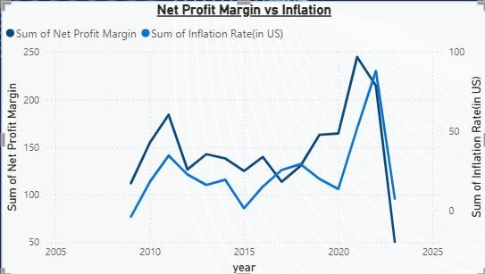

Interpretation
The analysis provides several important insights:

The overall correlation between Net Profit Margin and Inflation Rate is weak positive (0.21).
- Technology and banking sectors appear to benefit more from inflation, mainly due to strong pricing power and digital business models.
- FinTech, logistics, and semiconductor sectors are more sensitive to rising costs, resulting in weaker or negative relationships.
- The impact of inflation on profitability depends more on industry characteristics than on time period alone.

Chapter 7
Findings, Conclusion and Recommendations
  - Conclusion
The purpose of this study was to analyze financial performance and predict financial distress among selected companies using financial ratios and machine learning models. The research used financial statement data from twelve companies across different industries, including technology, banking, logistics, semiconductor, retail, and utilities.

The study examined several financial ratios such as liquidity, profitability, leverage, and efficiency indicators. In addition, statistical and machine learning techniques including correlation analysis, logistic regression, decision tree, and random forest models were applied to identify the key factors affecting financial distress.

The ratio analysis revealed that liquidity, profitability, and capital structure play important roles in determining the financial condition of companies. Firms with strong liquidity and higher profitability ratios generally showed better financial stability, while companies with weak profitability and unstable leverage ratios were more likely to experience financial distress.

The correlation analysis showed strong relationships among profitability indicators such as Return on Equity (ROE), Return on Assets (ROA), and Return on Investment (ROI). These results suggest that companies that efficiently utilize their assets and capital tend to generate better financial performance.

The study also examined the relationship between Net Profit Margin and Inflation Rate. The results indicated a weak positive overall correlation, suggesting that inflation affects companies differently depending on their industry characteristics. Technology and banking firms showed stronger positive relationships, while logistics and fintech companies showed weaker or negative relationships.

The predictive models provided important insights into financial distress identification. The logistic regression model indicated that Current Ratio and Return on Assets (ROA) are statistically significant predictors of financial distress.

The decision tree model achieved perfect classification accuracy in the test dataset, highlighting the importance of liquidity and profitability indicators in predicting financial distress.

Similarly, the random forest model demonstrated very high predictive accuracy, correctly classifying almost all observations. The model identified Current Ratio, ROA, and Interest Coverage Ratio as the most important variables influencing financial distress.

Overall, the findings suggest that financial ratios related to liquidity, profitability, and financial stability are the strongest indicators of corporate financial health.

Key Findings of the Study
The major findings of the study are summarized below:
    - Liquidity and profitability ratios are the most important indicators of financial stability.
    - Return on Assets (ROA) and Current Ratio were identified as the most significant predictors of financial distress.
    - Profitability ratios such as ROE, ROA, and ROI show strong positive relationships with each other.
    - Inflation has only a weak overall impact on corporate profit margins, but its effect varies across industries.

    - Technology and banking companies tend to perform better during inflationary periods compared to other sectors.
    - Machine learning models such as Decision Tree and Random Forest provide highly accurate predictions of financial distress.
    - Random Forest and Decision Tree models outperform traditional statistical models in financial distress prediction.

Recommendations
Based on the findings of this study, several recommendations can be made for investors, managers, and financial analysts.
    - Companies should maintain a strong liquidity position to ensure that short-term financial obligations can be met without difficulty.
    - Firms should focus on improving profitability and efficient asset utilization, as these factors significantly influence financial stability.
    - Companies should carefully manage their capital structure and debt levels to reduce financial risk and avoid potential distress.
    - Financial analysts and investors should monitor key financial ratios such as Current Ratio, ROA, and Interest Coverage Ratio when evaluating company performance.
    - Machine learning techniques such as Random Forest and Decision Trees can be used by financial institutions and investors to identify financially distressed firms at an early
stage.
    - Companies should consider industry-specific factors and macroeconomic conditions such as inflation when making financial and strategic decisions.

Scope for Future Research
Although this study provides useful insights into financial distress prediction, there are several opportunities for future research.

Future studies may include a larger number of companies across different countries and industries to improve the generalizability of the results.

Researchers can also incorporate additional financial indicators such as cash flow ratios, market indicators, and corporate governance variables.

Advanced machine learning techniques such as neural networks, gradient boosting models, and deep learning approaches may also be applied to improve prediction accuracy.
Furthermore, future studies may examine the impact of macroeconomic variables such as interest rates, GDP growth, and exchange rates on corporate financial distress.

References
    - Altman, E. I. (1968). Financial ratios, discriminant analysis and the prediction of corporate bankruptcy. The Journal of Finance, 23(4), 589–609.
    - Beaver, W. H. (1966). Financial ratios as predictors of failure. Journal of Accounting Research, 4, 71–111.
    - Breiman, L. (2001). Random forests. Machine Learning, 45(1), 5–32.
    - Chen, N., Roll, R., & Ross, S. A. (1986). Economic forces and the stock market. The Journal of Business, 59(3), 383–403.
    - Damodaran, A. (2012). Investment valuation: Tools and techniques for determining the value of any asset (3rd ed.). John Wiley & Sons.
    - Fama, E. F., & French, K. R. (1992). The cross-section of expected stock returns. The Journal of Finance, 47(2), 427–465.
    - James, G., Witten, D., Hastie, T., & Tibshirani, R. (2021). An introduction to statistical learning: With applications in R (2nd ed.). Springer.
    - Ross, S. A., Westerfield, R., & Jaffe, J. (2019). Corporate finance (12th ed.). McGraw-Hill Education.
    - Shumway, T. (2001). Forecasting bankruptcy more accurately: A simple hazard model.
The Journal of Business, 74(1), 101–124.
    - Stock, J. H., & Watson, M. W. (2020). Introduction to econometrics (4th ed.). Pearson Education.

Appendix

Secondary Data from Kaggle – Secondary Data from Kaggle.xlsx
    - Financial Statement (chapter 4), Financial Ratios (Chapter 5), Overall Analysis of the 12 Companies (Chapter 6 – Part 2) –

Financial Statements.xlsx

    - Descriptive Analysis, Correlation Analysis, Trend Analysis of Individual Company -
      - Apple Inc. - AAPL.xlsx
      - American International Group – AIG.xlsx
      - Amazon.com Inc. – Amzn.xlsx
      - Barclays PLC - BSC.xlsx
      - Alphabet Inc. (Google) – GOOG.xlsx
      - Intel Corporation – INTC.xlsx
      - McDonald's Corporation – MCD.xlsx
      - Microsoft Corporation - MSFT.xlsx
      - NVIDIA Corporation – NVDA.xlsx
      - Pacific Gas & Electric – PCG.xlsx
      - PayPal Holdings Inc. – PYPL.xlsx
      - Sears Holdings Corporation – SHLDQ.xlsx
    - Logistic Regression Using R Language –

Logistic Regression & Confusion Matrix.R

Decision Tree Using Python –
decision_tree.py

Random Forest Using Python –
random_forest.py

Financial Distress Dashboard Using Power BI –

ROC Curve (Rplot) –

